
Diesel Fuel Management System
User Manual — The Diesel Workflow
Request & Planning · Approval · Delivery on Site · Reconciliation
Technician · Diesel Manager · Admin · Supervisor · Finance · Head of Business · CEO
Prepared 23 September 2026

Table of Contents
If this section looks empty, right-click anywhere below this line and choose "Update Field" (or select this whole page and press F9) to generate it.

Chapter 1 — How to Use This Manual

1.1 Who This Manual Is For
This manual covers the diesel fuel workflow of the GRATO Diesel Fuel Management System, end to end: requesting and planning fuel, approving a request, delivering it on site, and reconciling what was budgeted against what was actually used. It is organized around that flow rather than around individual roles, because a single fuel request passes through several different people’s hands — a technician, a Diesel Manager, up to five approvers, and back to a technician again. Each chapter names exactly who does what at that stage. If you only care about your own role, use the "Roles at a Glance" table in Chapter 2 to jump straight to the sections that involve you.
This version of the manual deliberately leaves out Preventive Maintenance, Corrective Maintenance (parts/repairs), and the equipment/HSE/comprehensive site audits — those are separate workflows in the same app, outside the scope of a diesel-focused manual.

1.2 About the Screenshots
Every screen in this manual is illustrated with a real screenshot taken from the live system, captioned in small italic grey text below the image (e.g. "Figure 12. Refueling Entry Form").

Chapter 2 — System Overview

2.1 The Diesel Fuel Lifecycle
Every litre of diesel the system tracks moves through the same four stages, and this manual is organized around them, one chapter each:
- Chapter 3 — Request & Planning: deciding which sites need fuel and how much, setting budgets, and raising a formal fuel request (mobile or web).
- Chapter 4 — Approval: the request moves through up to six approvers in sequence — Diesel Coordinator, Operations Manager, Technical Director, Finance, Head of Business, and (for larger requests) CEO.
- Chapter 5 — Delivery on Site: a technician is assigned the approved request, travels to the site, buys or draws down fuel, and reports the actual delivery from the mobile app.
- Chapter 6 — Reconciliation: what was budgeted, requested, purchased, and delivered is cross-checked against tank readings, telemetry, and card spend to catch discrepancies.
The mobile app (field technicians) and the web dashboard (everyone else) meet at the request: it can start on either one, and always ends with a technician reporting the delivery back from the mobile app, closing the loop.

2.2 Signing In
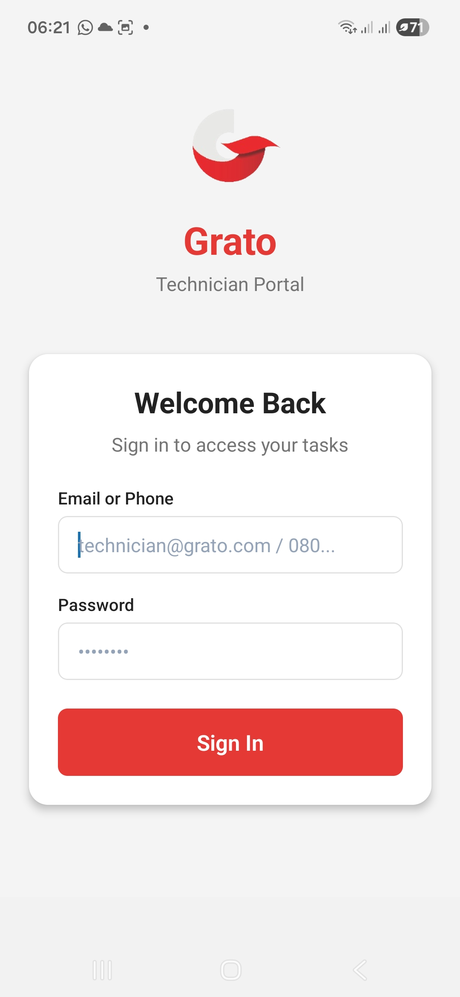
Figure 1. Mobile App — Login Screen
On the mobile app, sign in with the email and password your administrator gave you. You stay signed in on that device until you sign out from your Profile screen.
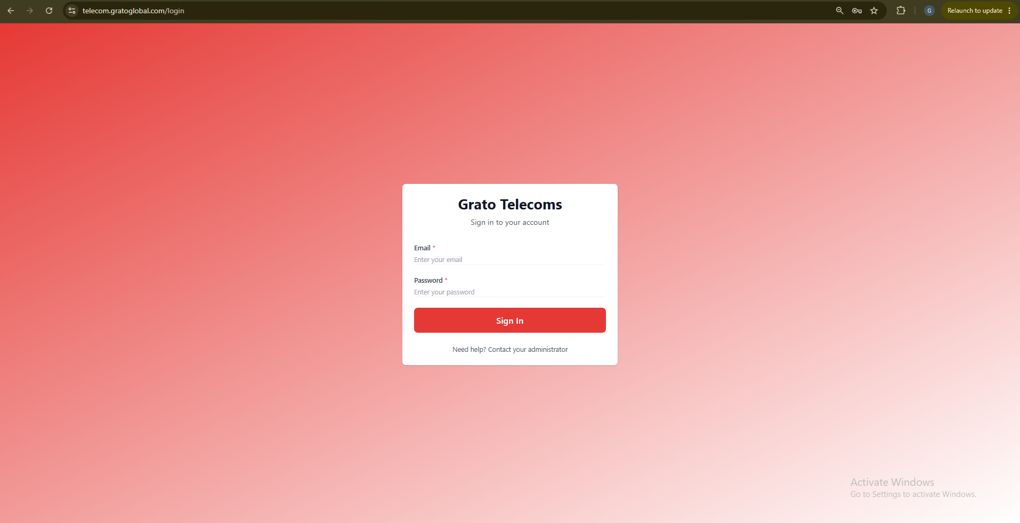
Figure 2. Web Login Screen
On the web dashboard, sign in the same way at the login page — you’ll land on your role’s own portal automatically.

2.3 Roles at a Glance
Find your role below and jump straight to the sections that involve you — you don’t need to read every chapter.
- Technician (mobile app) — raises fuel requests and delivers approved ones on site. Chapters 3 and 5.
- Diesel Manager — runs day-to-day fuel operations: planning, budgets, uploads, approvals, and reconciliation. Chapters 3, 4, 5, and 6.
- Admin — configures who the six approvers are. Chapter 4.
- Supervisor — signs off on fuel requests from their team, alongside their (out-of-scope) maintenance-approval duties. Chapter 4.
- Finance Officer — Level 4 approver, and the one who disburses payment. Chapter 4.
- Head of Business — Level 5 approver, with cluster-wide spend oversight. Chapter 4.
- CEO — Level 6 (final) approver, for requests of 100L or more. Chapter 4.
- Data Collector — shares some of the Diesel Manager’s upload pages; no separate diesel workflow of its own. See section 6.15.
- Operations — has no diesel-specific responsibilities; its portal is dedicated to comprehensive site audits, which are outside this manual’s scope. See section 6.16.

2.4 The Billing Cycle
Most diesel-related pages are scoped to a billing cycle (a calendar month, e.g. "2026-09"). A Cycle Selector near the top of the page lets you switch which month’s data you’re viewing. Budgets, requests, reconciliation, and reporting all follow whichever cycle is selected.

Chapter 3 — Request & Planning
This chapter covers deciding which sites need fuel, making sure the right budget is in place to cover it, and raising a formal fuel request — the step that starts the approval chain in Chapter 4. Most of this chapter is the Diesel Manager’s work on the web dashboard; raising a request is also something a technician does directly from the mobile app.

3.1 Diesel Manager: Deciding Where Fuel Is Needed

Fuel Planning Engine
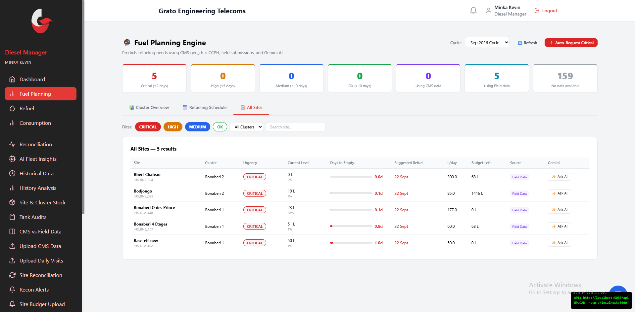
Figure 3. Fuel Planning Engine — predicted days to empty, by site
Predicts how many days each site has left before it runs dry, using recent consumption and current tank level.
- View each site’s predicted "days to empty" and urgency (critical / high / medium / ok).
- Auto-generate a refueling schedule, or auto-raise fuel requests for critical sites.
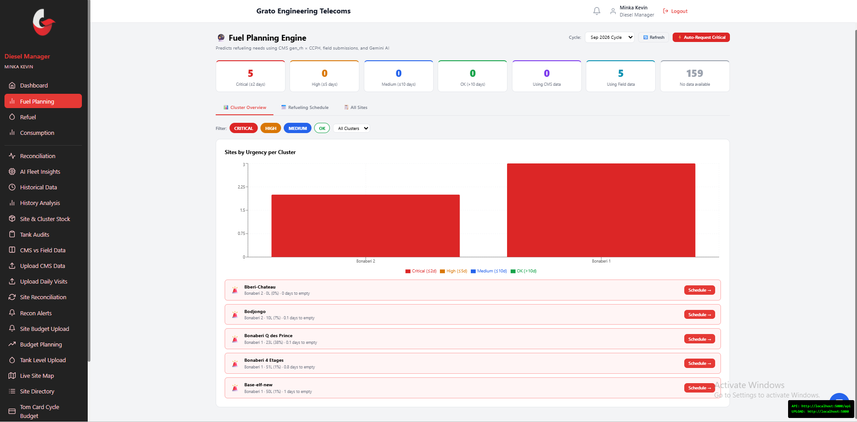
Figure 4. Fuel Planning Engine — sites grouped by urgency per cluster

Low Fuel Alerts
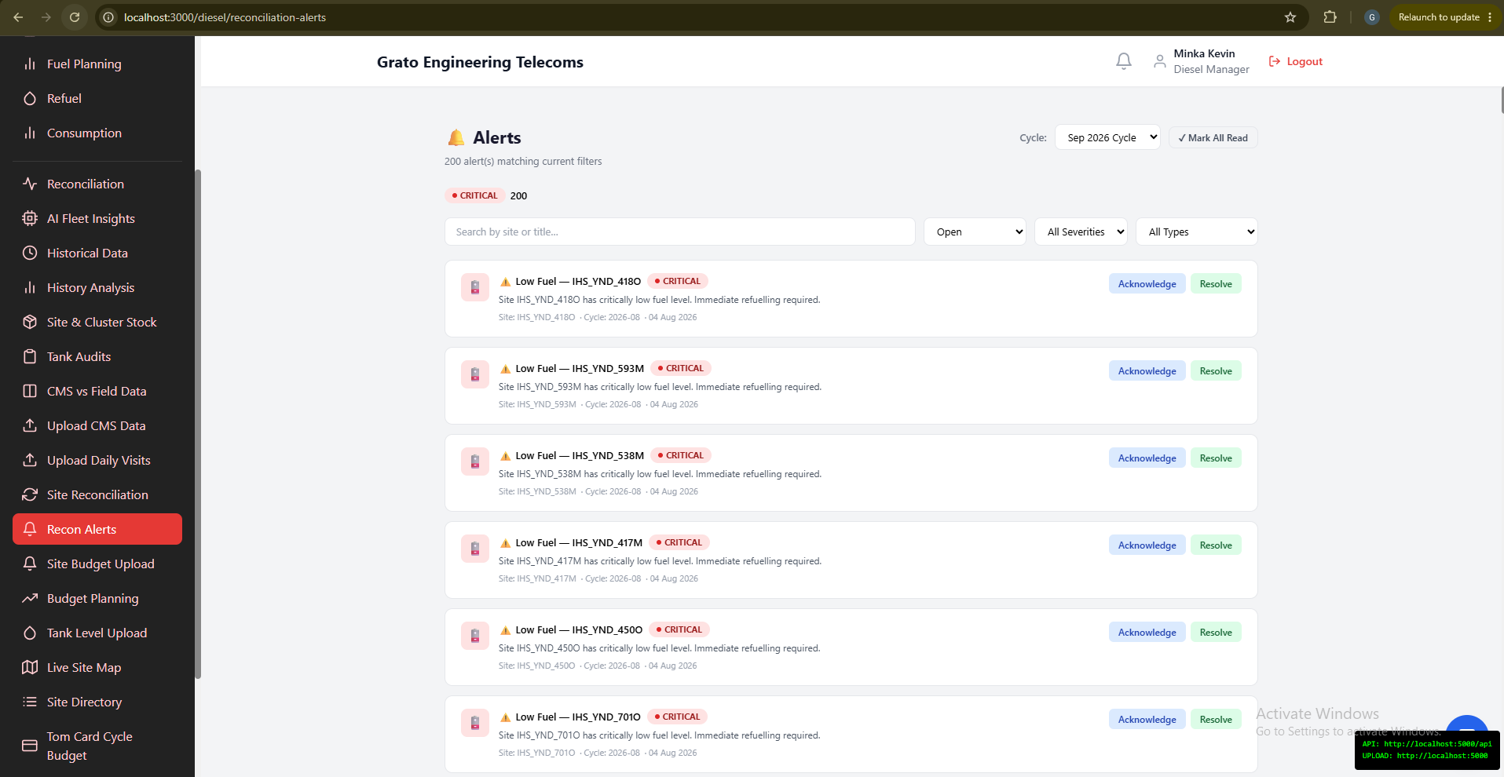
Figure 5. Low Fuel Alerts
A dedicated list of sites running low, grouped by urgency. Choose a fuel-percentage threshold to filter which sites appear.

Live Site Map
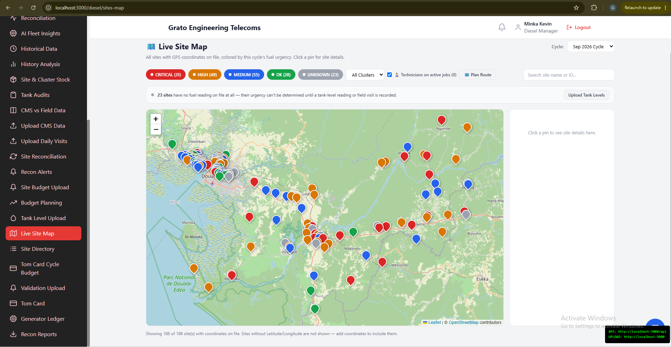
Figure 6. Live Site Map
An interactive map of every site with valid coordinates. Pins are colored by current fuel urgency for the selected cycle — spot critical sites at a glance.

Site Directory
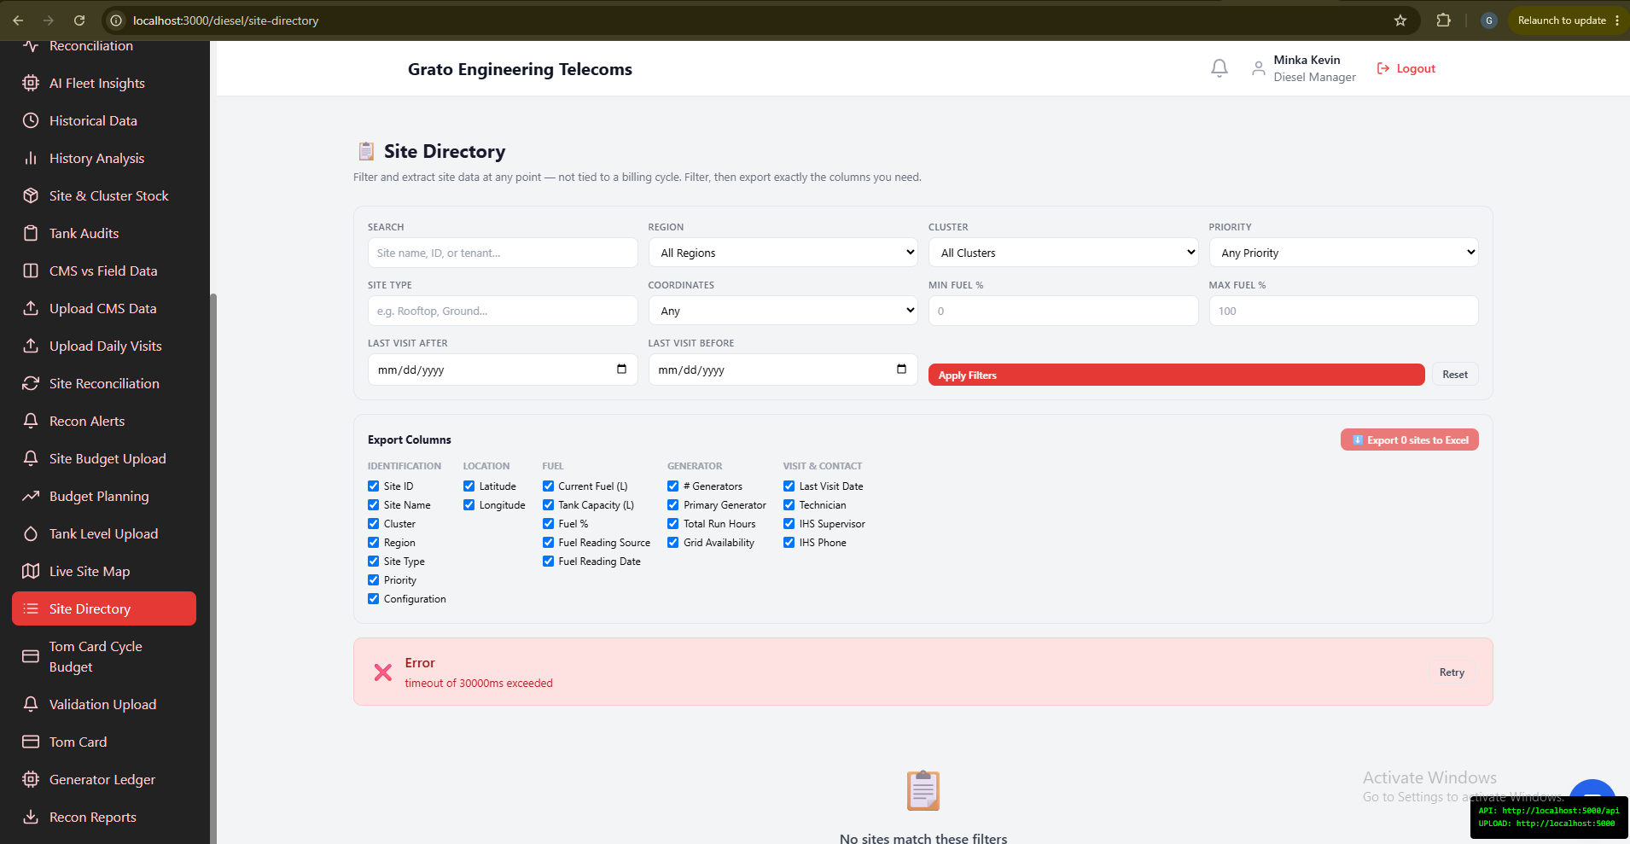
Figure 7. Site Directory
A flexible site browser and exporter, not tied to a billing cycle. Filter sites by whatever criteria you need, pick exactly which columns to include, then export to Excel.

3.2 Diesel Manager: Setting the Budget
A fuel request is checked against budget at approval and reconciliation time — these three pages are where that budget actually gets set for the cycle.

Site Budget Upload
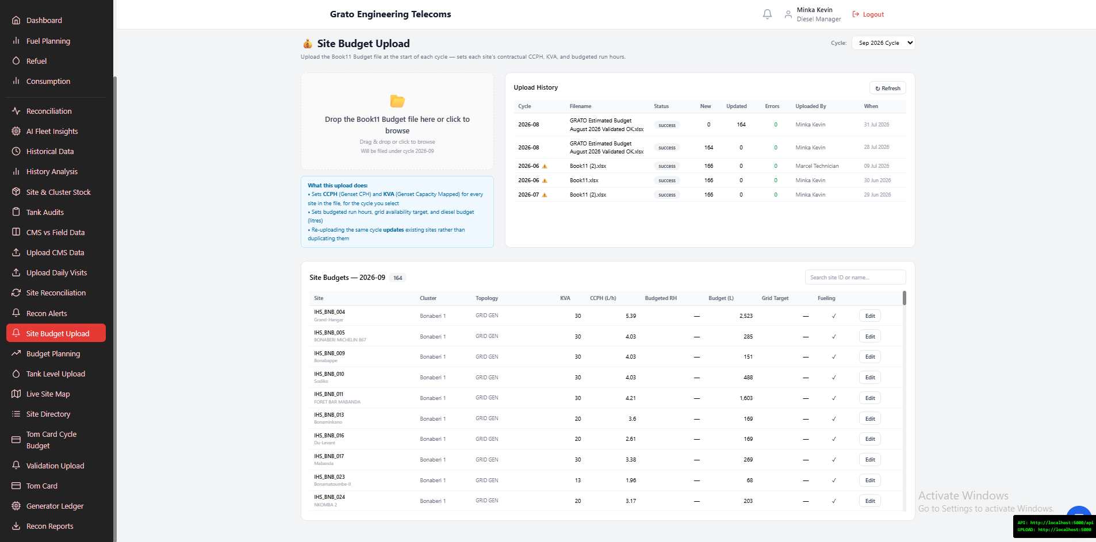
Figure 8. Site Budget Upload
Upload the per-site budget file for the cycle.
- Choose the cycle first — this file has no date column, so upload is disabled until you pick one.
- Use the inline-editable table to correct a single site’s figures without re-uploading the whole file.

Tom Card Cycle Budget Upload
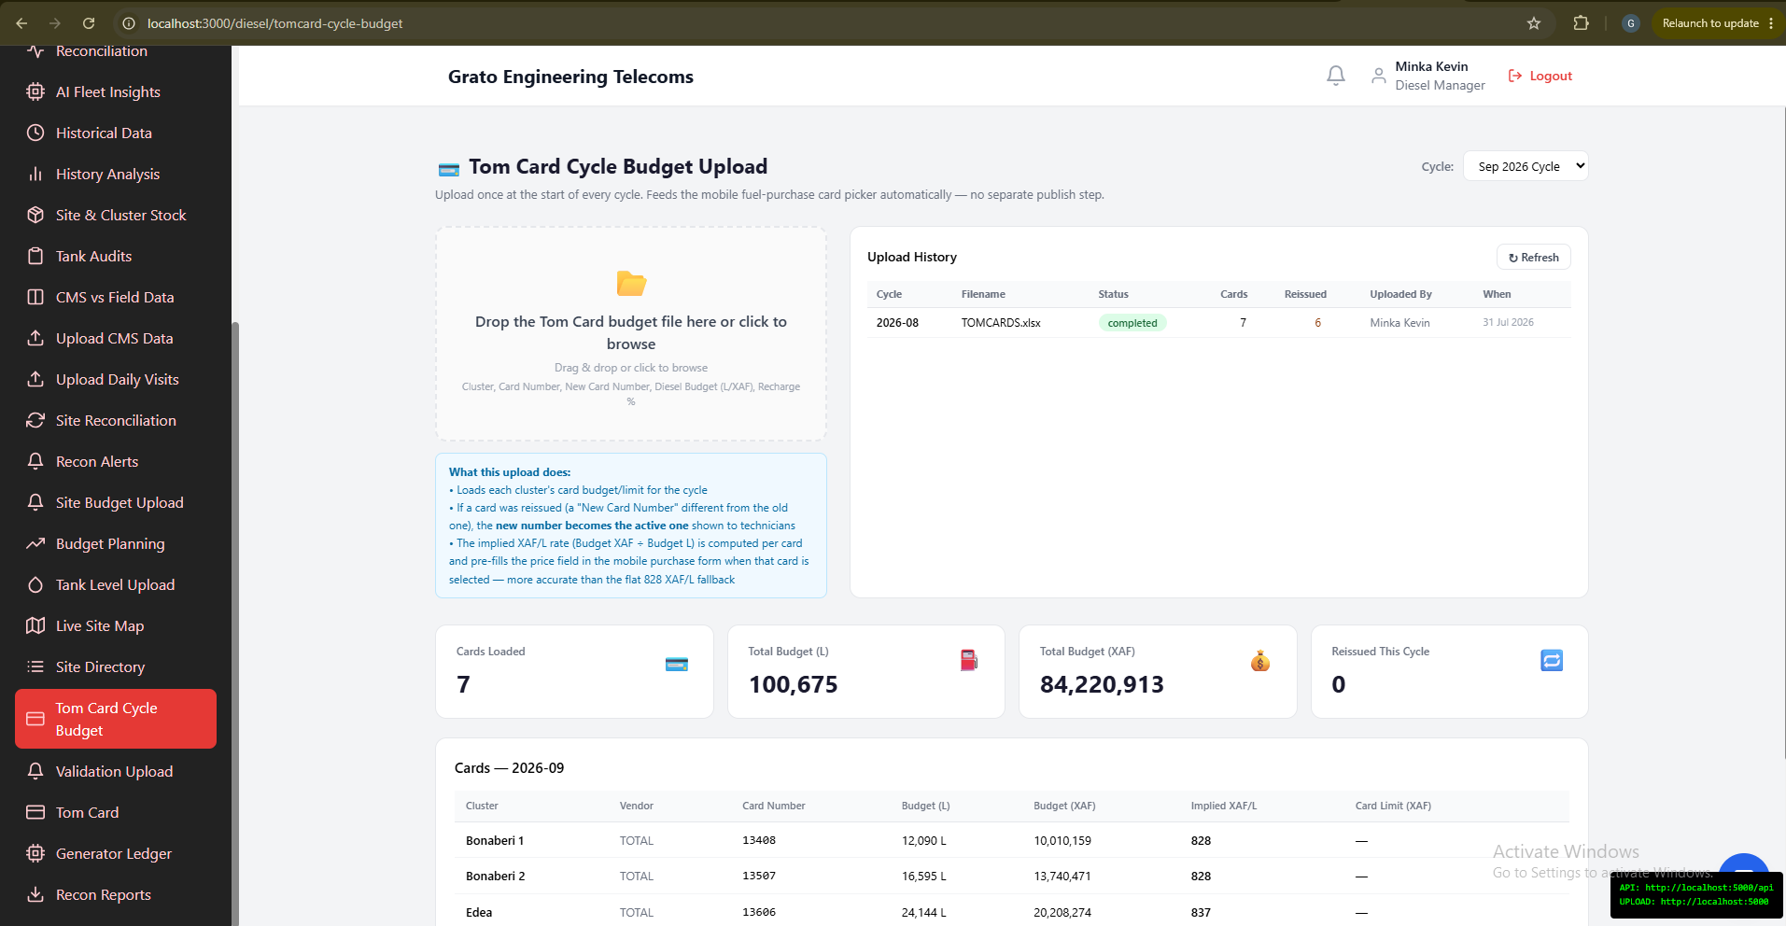
Figure 9. Tom Card Cycle Budget Upload
Upload the cycle-opening Tom Card (fuel purchase card) budget/limit file. Pick the cycle first — the file has no date column.
ℹ Note: Once uploaded, this automatically feeds the mobile app’s fuel-purchase card picker for that cycle (section 5.2) — nothing further to publish.

Automated Budget Planning
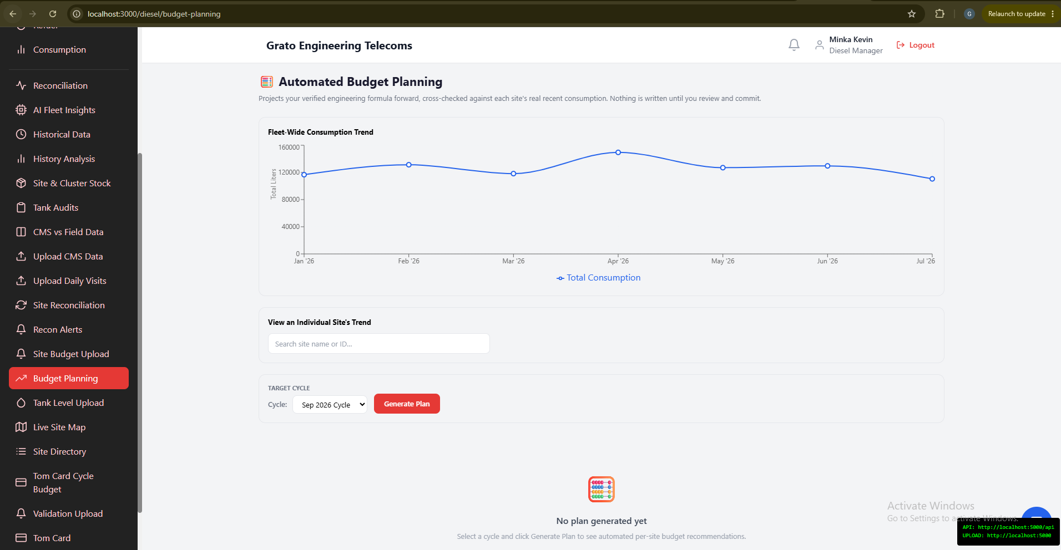
Figure 10. Automated Budget Planning
Generates next cycle’s budget automatically, before you commit to it.
- Review a preview per site, cross-checked against recent real consumption (flagged high/medium/low confidence where they disagree).
- Nothing is written to real budget data until you explicitly review and commit the preview.

3.3 Technician: Raising a Fuel Request (Mobile)
Use this when a site needs fuel and you want formal approval first — including sites that are not on your scheduled list. This is different from reporting a refuel that is already happening (Chapter 5) — Request Fuel is for getting approval before fuel is bought.
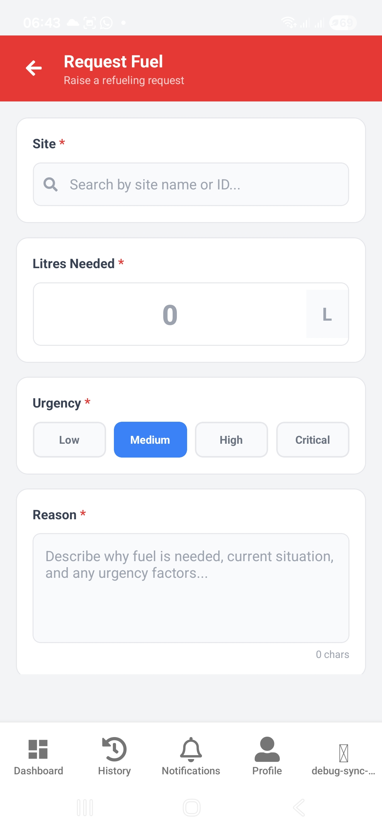
Figure 11. Request Fuel Form
Fill in:
- Site — search by name or ID. This search is unrestricted: you can select any site in the system, not only ones scheduled to you.
- Litres Needed — shows a live cost estimate in XAF. Requests of 100L or more require CEO approval, shown as a badge.
- Urgency — Low, Medium, High, or Critical.
- Reason — describe why fuel is needed.
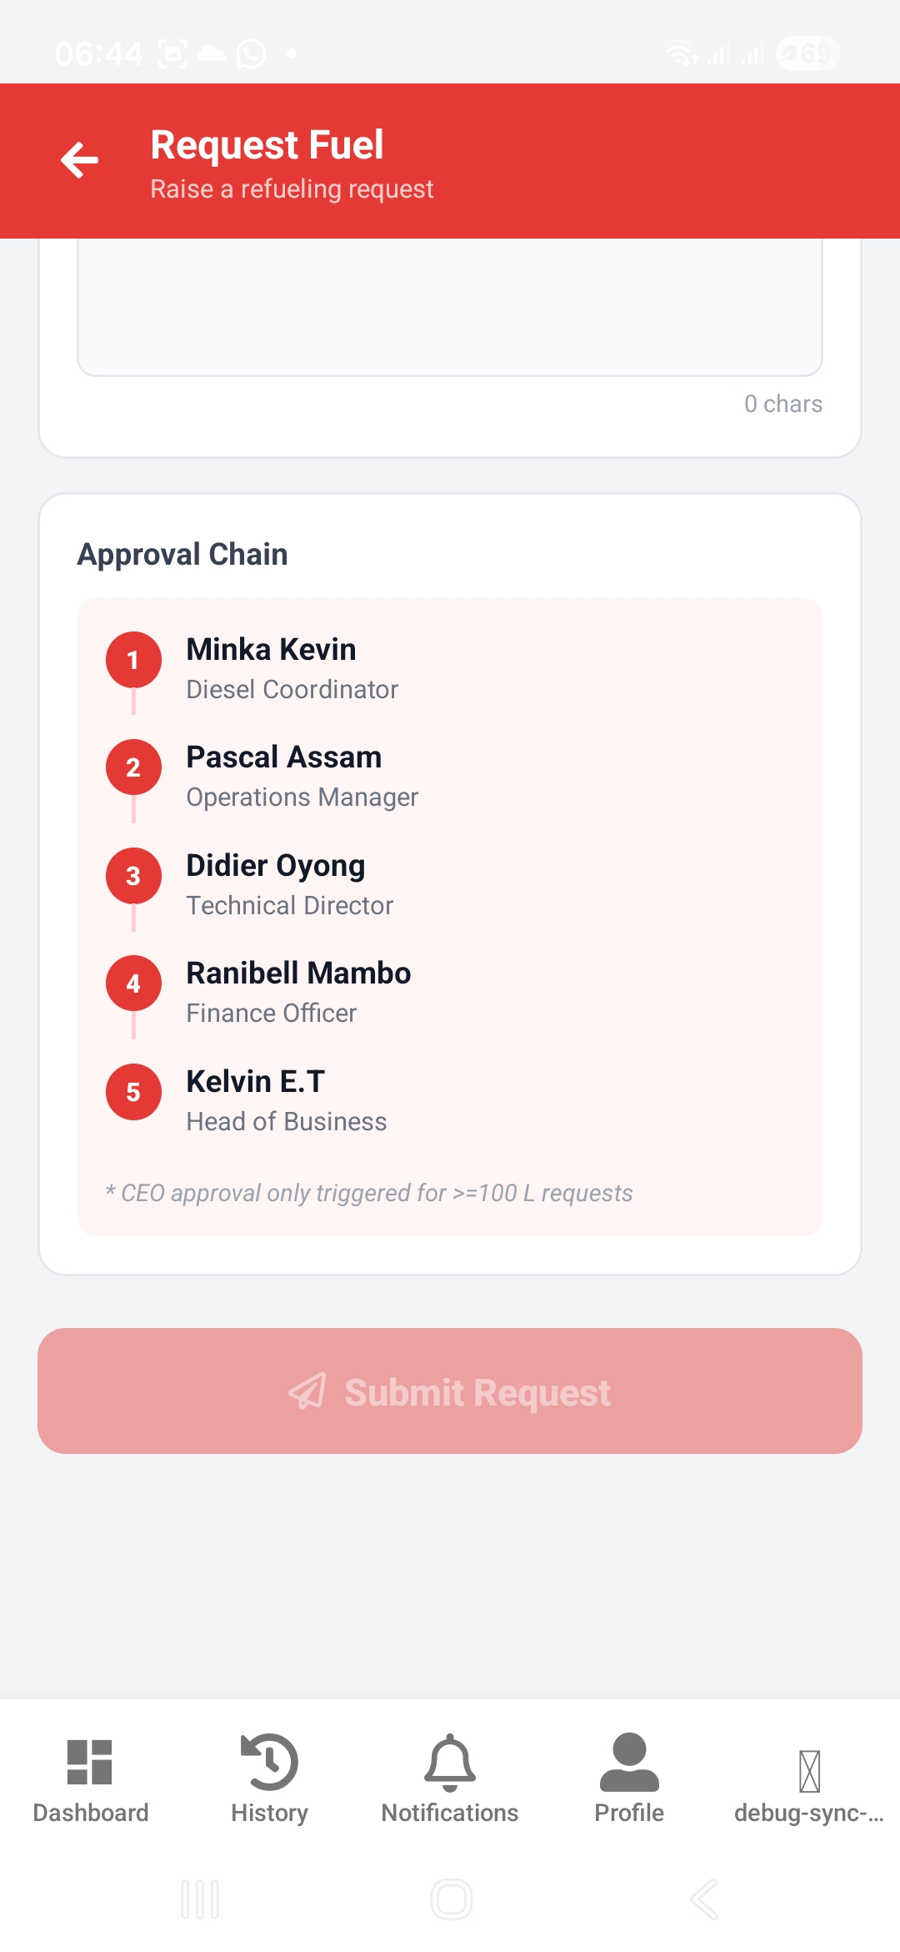
Figure 12. Approval Chain Preview — the six approver levels
⚠ Important — Critical Urgency = Emergency Refueling: Selecting Critical marks the request as an emergency. Instead of going through each approver one at a time, ALL approvers (Diesel Coordinator, Operations Manager, Technical Director, Finance, Head of Business, and CEO if ≥100L) see it on their dashboard at the same time. Whoever approves FIRST schedules it immediately — nobody has to wait for the rest of the chain. Only use Critical for genuine emergencies — see Chapter 7.
Tap Submit Request.
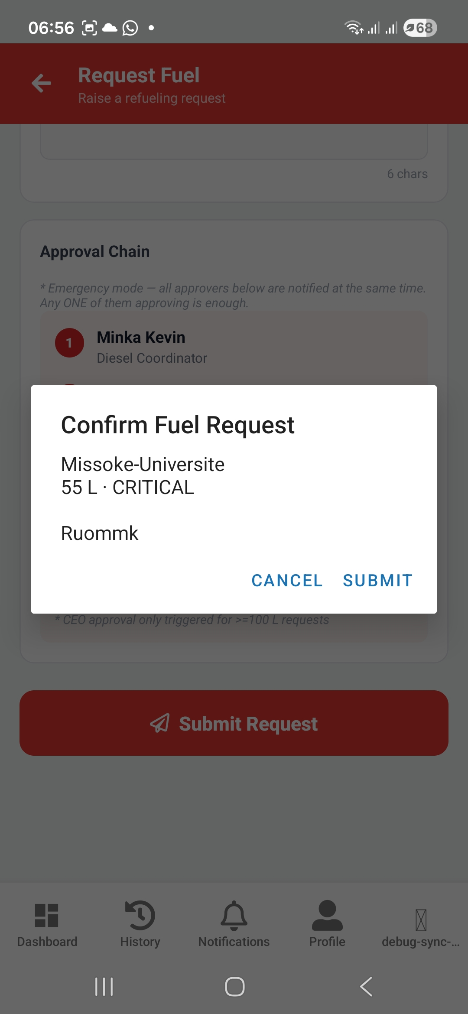
Figure 13. Confirm Fuel Request
Confirm the site, litres, and urgency shown. If you’re offline, the request is saved and sent automatically once you reconnect.
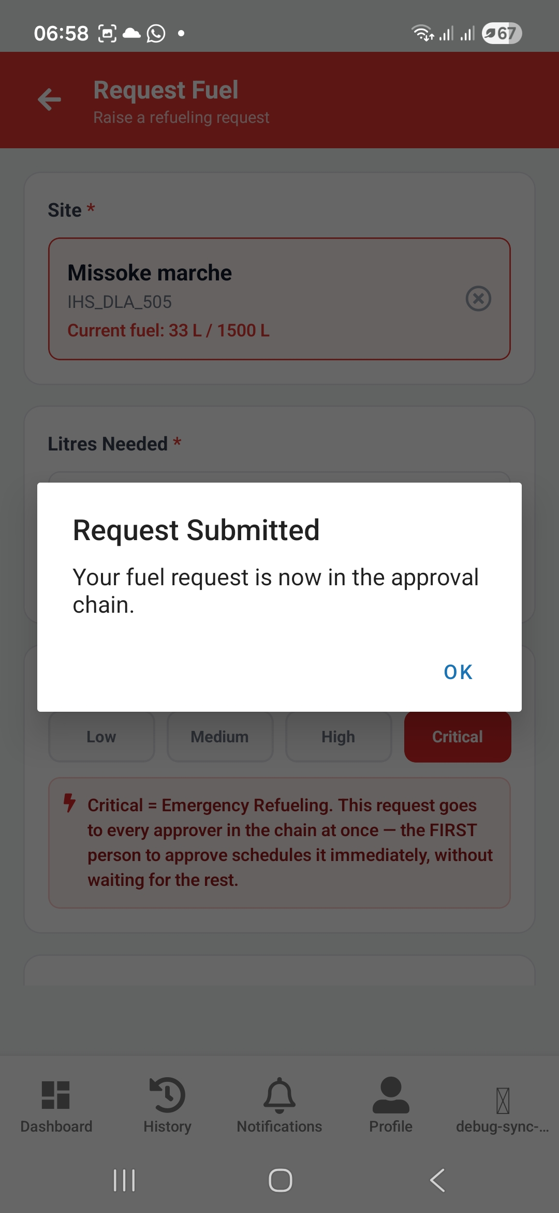
Figure 14. Request Submitted
The request is now in the approval chain — see Chapter 4 for what happens next, and section 5.3 for where to find it once it’s approved and ready to deliver.

3.4 Diesel Manager: Raising a Fuel Request (Web)
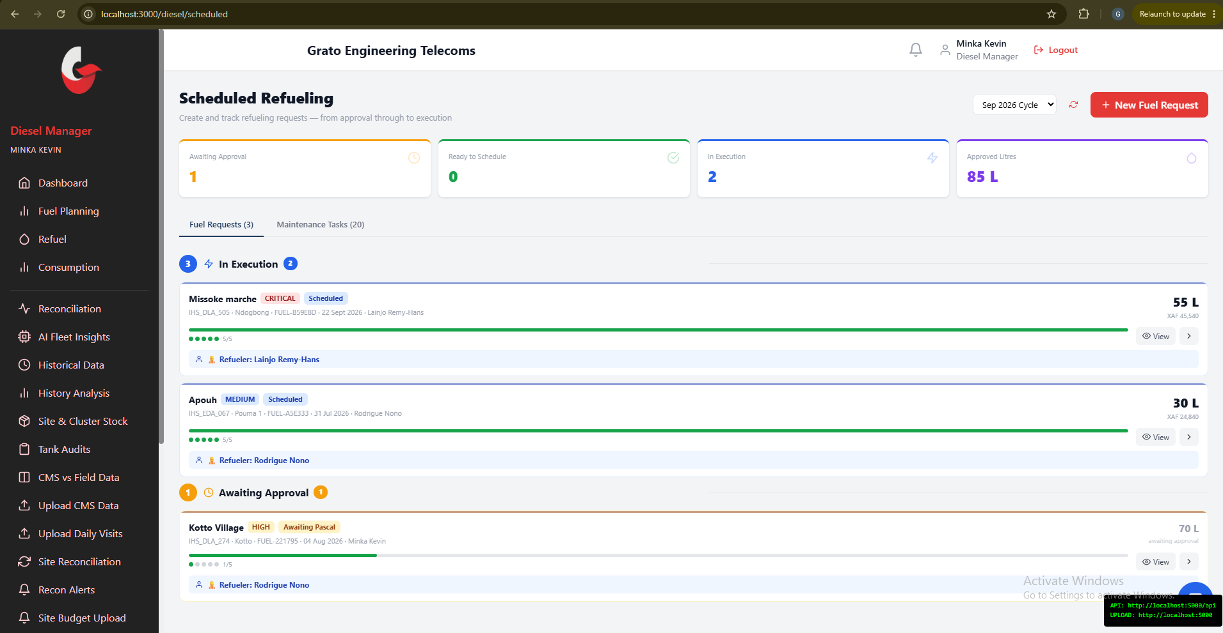
Figure 15. Scheduled Refueling
New fuel requests can also be created on the web, from the Scheduled page.
- New Fuel Request — pick a site, enter litres, and give a reason (shows a live fuel-level preview and cost estimate).
- Track requests through three stages: Awaiting Approval, Ready to Schedule, Active/Executing.
ℹ Note: Assigning an approved request to a technician for delivery happens on this same page — see section 5.1.

3.5 Emergency Refueling (Critical Urgency)
A request raised with Critical urgency — on mobile (3.3) or web (3.4) — skips the normal one-at-a-time approval order: every approver sees it immediately, and whichever one approves first schedules it right away. Only use Critical for a genuine emergency. See Chapter 7 for the full quick-reference summary of how this works for both the technician raising the request and every approver in the chain.

Chapter 4 — Approval
Once a fuel request is raised (Chapter 3), it has to be approved before anyone can buy or deliver fuel against it. This chapter covers the approval chain itself, and every role’s own approval screen.

4.1 The Approval Chain
A fuel request moves through up to six approval levels in order:
- 1. Diesel Coordinator
- 2. Operations Manager
- 3. Technical Director
- 4. Finance Officer — can also adjust the approved litres before signing off
- 5. Head of Business
- 6. CEO — only required when the request is 100L or more
A request created with Critical urgency (an "Emergency Refueling," section 3.5 and Chapter 7) skips this one-at-a-time order — every approver sees it immediately, and whichever one approves first schedules it right away.
ℹ Note: Who fills each of the six roles is configured by an Admin on the Approval Chain page (section 4.2) — if a person’s email is wrong there, requests will email the wrong inbox.

4.2 Admin: Configuring the Approval Chain
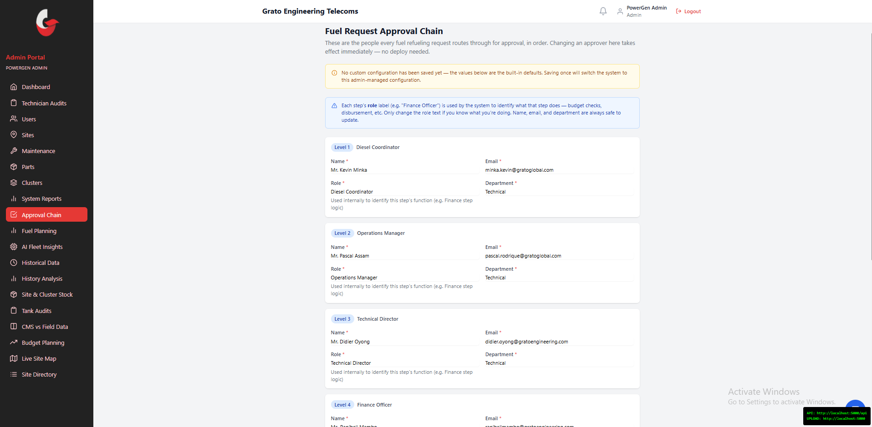
Figure 16. Fuel Request Approval Chain — Levels 1–3
Configure who the six fuel-request approvers actually are — this feeds every approval anywhere in the system.
- Edit each level’s Name, Email, Role, and Department.
- Set the CEO litres threshold (default 100L) — requests at or above this also need CEO approval.
- Save changes — they take effect on the very next fuel request; no restart needed.
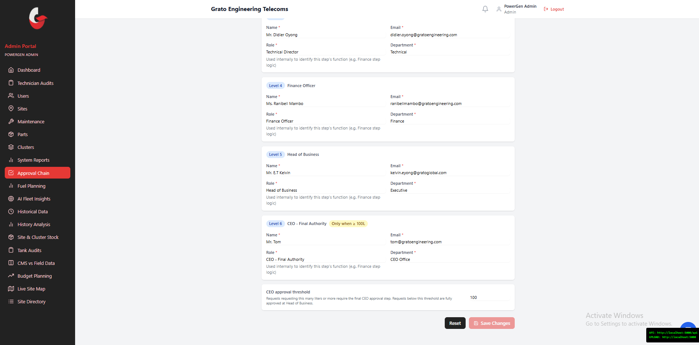
Figure 17. Fuel Request Approval Chain — Levels 4–6 and the CEO threshold
⚠ Warning: If an approver’s email is wrong here, their approval notifications go to the wrong inbox with no visible error. Double-check every email after editing.

4.3 Diesel Manager: Reviewing & Approving Requests
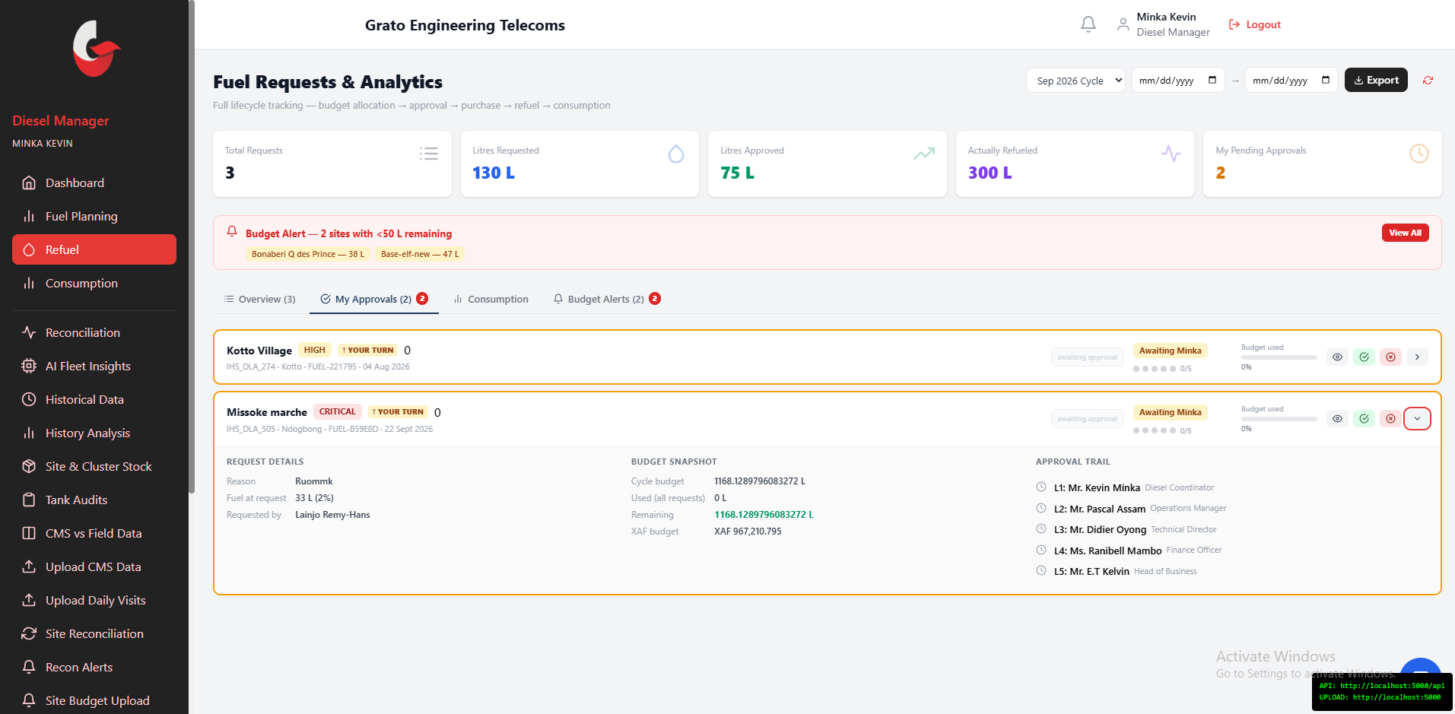
Figure 18. Fuel Requests & Analytics — My Approvals tab
The Fuel Requests & Analytics page tracks a request’s full lifecycle (Budget Allocated → Requested → Approved → Purchased → Refueled → Consumed). Its My Approvals tab lists whatever is waiting on your own sign-off.
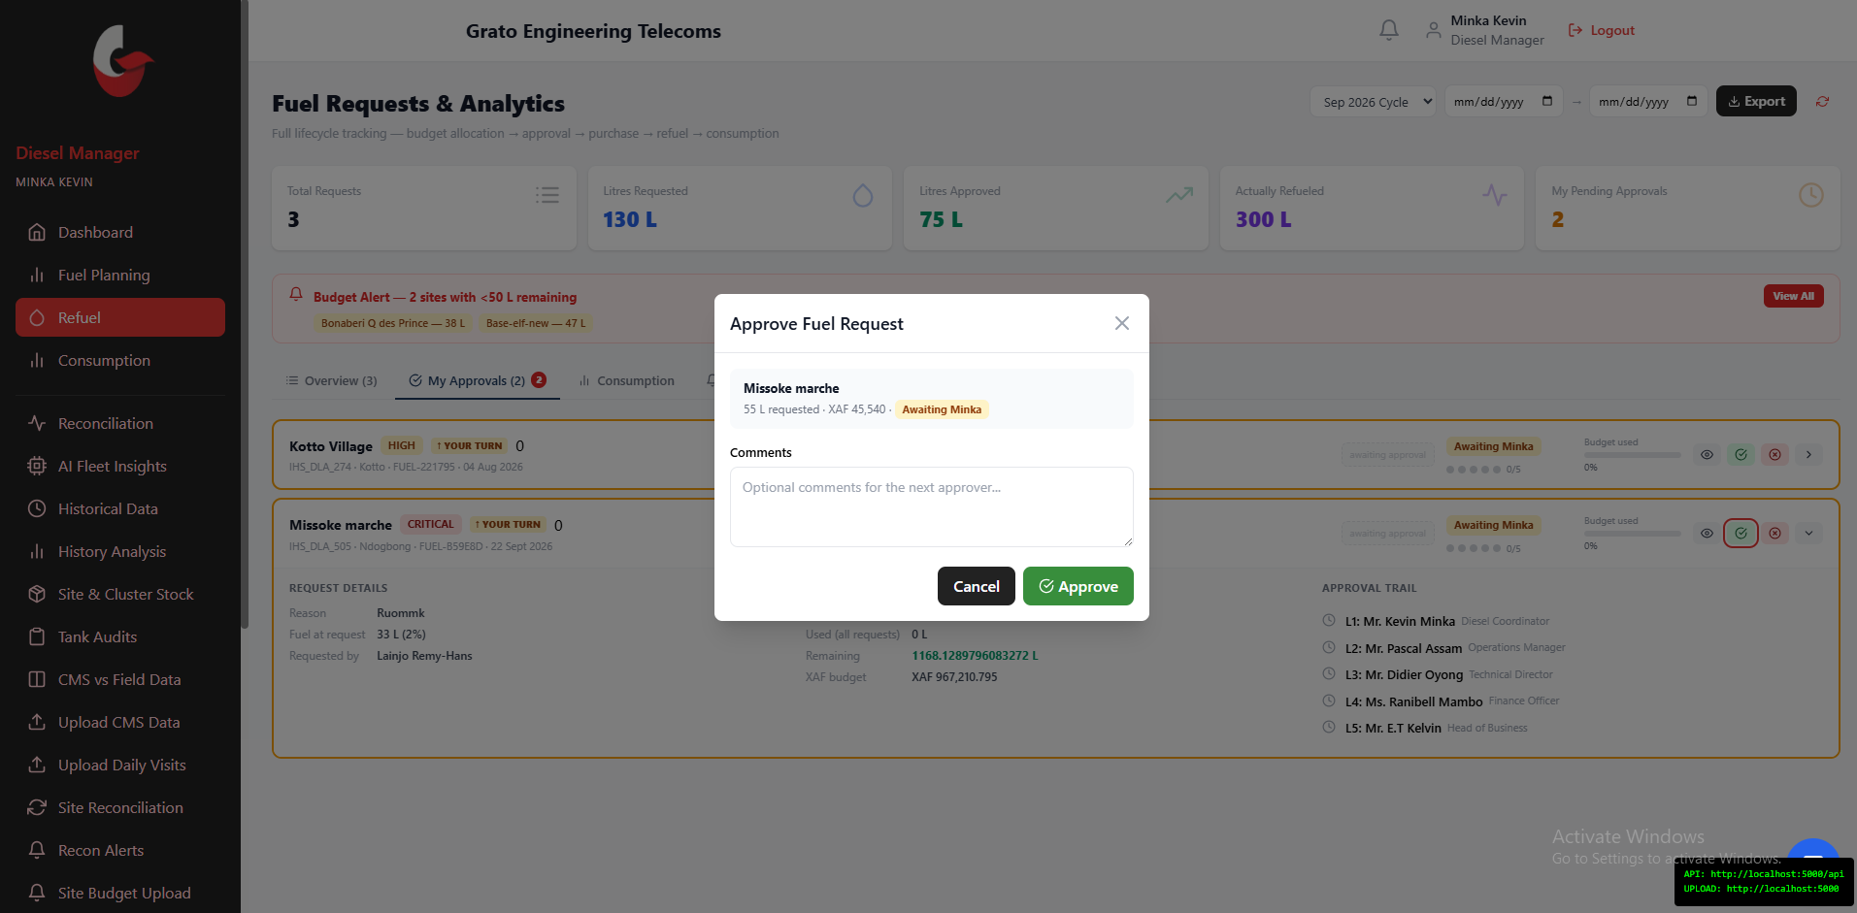
Figure 19. Approve Fuel Request
Open a request and tap Approve (with optional comments) or Reject. New requests are created from the Scheduled page (section 3.4), not here — this page is for tracking and approving.

4.4 Supervisor: Fuel Approvals
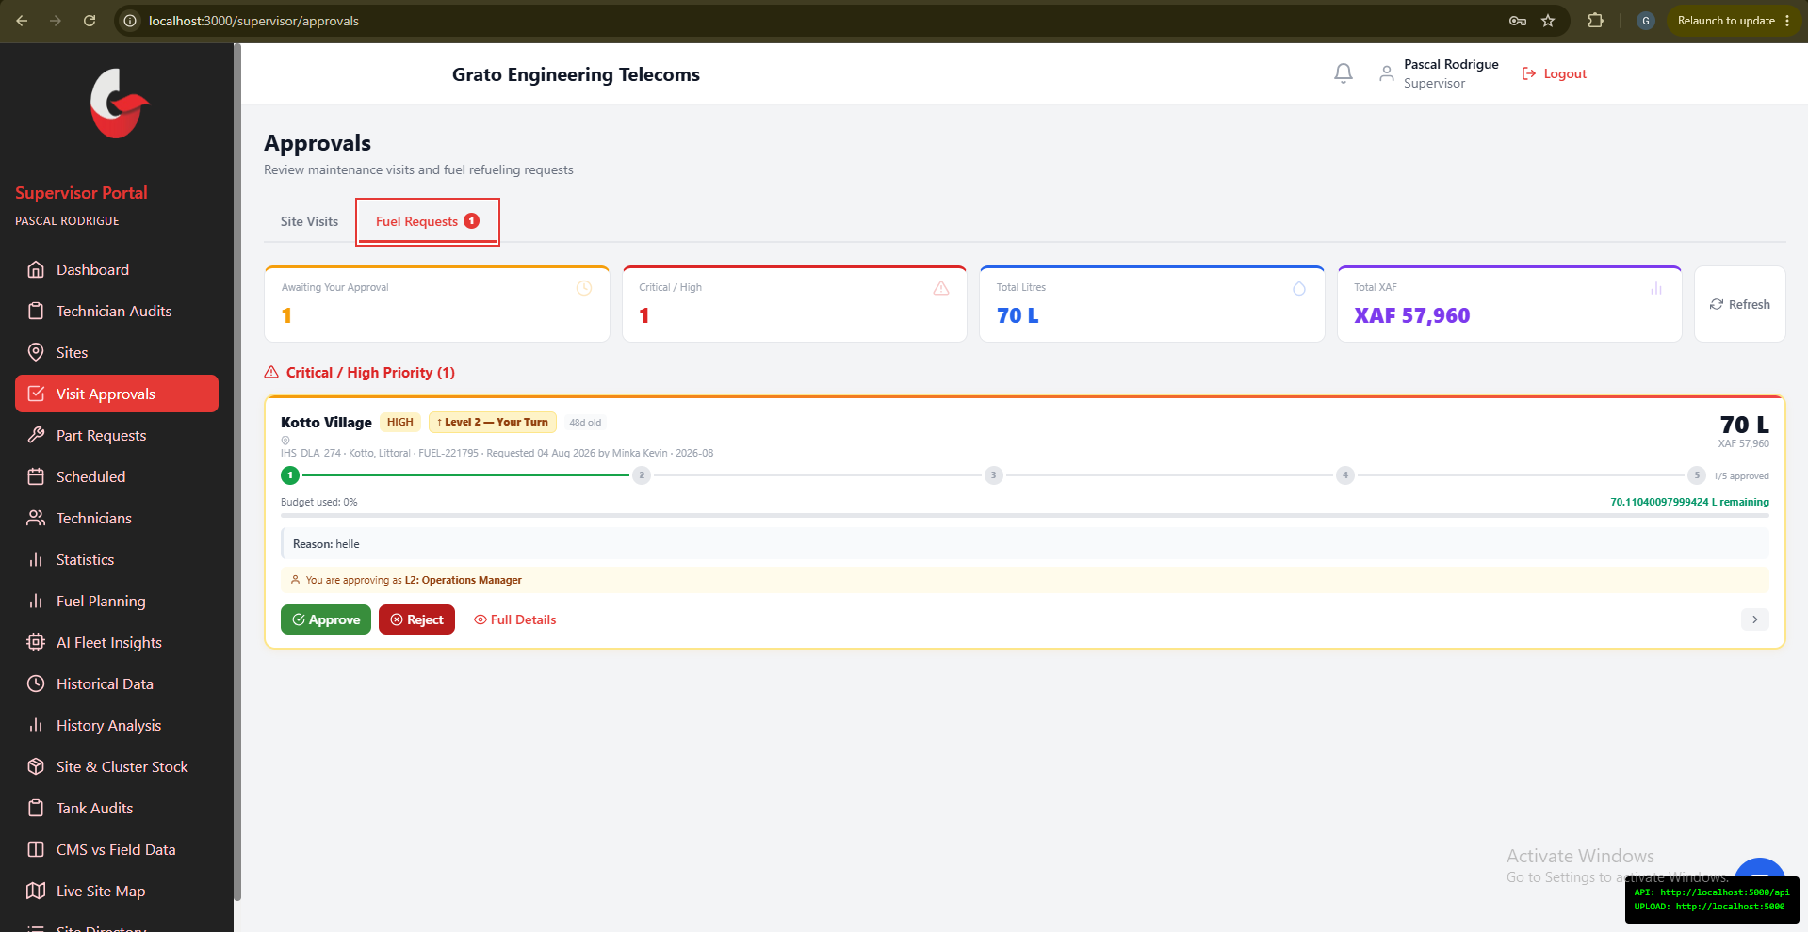
Figure 20. Supervisor Portal — Approvals (Fuel Requests)
Fuel requests from your team appear here alongside your other (maintenance) approval duties — the Fuel Requests tab is the one relevant to this manual. Review the request detail and Approve (with optional comments) or Reject (reason required), sorted by priority.

4.5 Finance Officer: Approvals & Disbursement
As the Finance Officer, you are Level 4 of the approval chain — the only level that can adjust the approved litres before signing off, and the one responsible for actually disbursing payment.
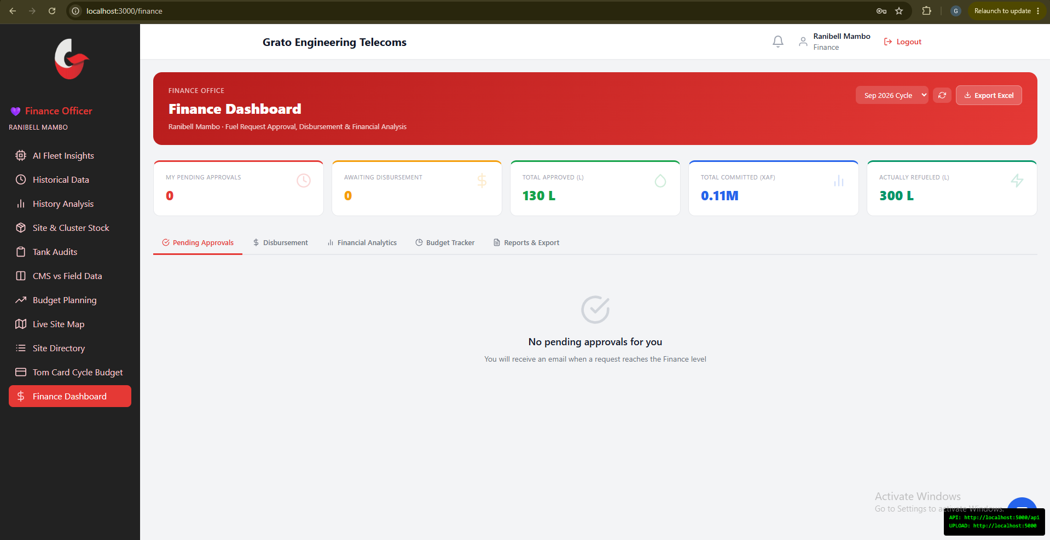
Figure 21. Finance Dashboard
Your dashboard has five tabs, with a cycle selector driving all of them:
- Approvals — requests waiting on you. Review the full cost breakdown, optionally adjust the approved litres, then Approve (with comments) or Reject (reason required). An emergency-approve override is also available here for genuine emergencies.
- Disbursement — fully-approved requests awaiting payment. Mark a request as disbursed, attach a reference number, and record the actual XAF paid.
- Analytics — monthly spend vs. budget, cluster breakdowns, cost-per-litre trend, and consumption variance.
- Budget Tracker — per-cluster allocation vs. committed vs. actual spend, including Tom Card vs. field reconciliation.
- Reports — generate and export XLSX/PDF finance reports.

4.6 Head of Business: Approvals
As Head of Business, you are Level 5 of the approval chain, with broader oversight of spend and team performance across every cluster.
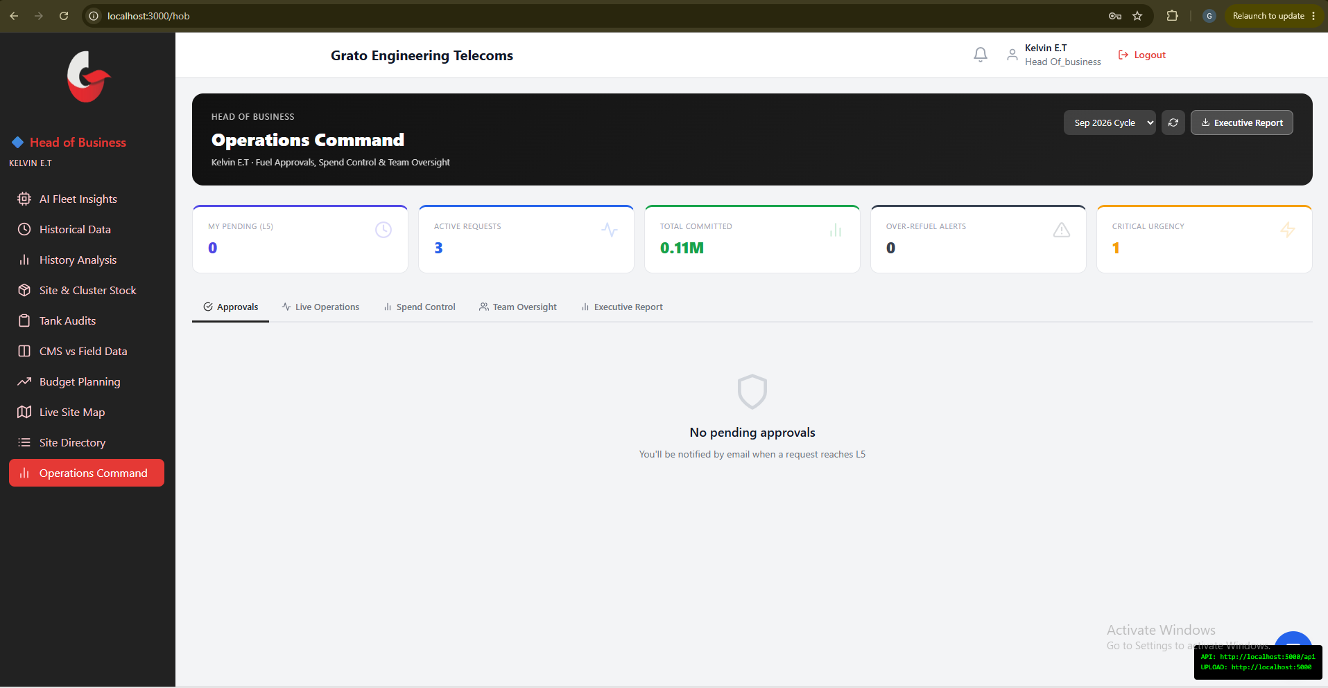
Figure 22. Head of Business Dashboard
Your dashboard has five tabs:
- Approvals — pending Level-5 requests with full history and cost detail. Approve, Reject, or use the emergency-approve override.
- Operations — a live view of every active fuel request across all clusters.
- Spend Control — budget vs. spend by cluster, over-refuel alerts, anomaly flags, and cost-efficiency metrics.
- Team Oversight — who approved what and how fast, including visibility into when Finance adjusted a requested amount.
- Executive Report — a monthly summary formatted to share upward with the CEO, exportable to Excel.

4.7 CEO: Final Approvals
As CEO, you are the final approval level (Level 6) — only engaged for requests of 100L or more (configurable by an Admin, section 4.2).
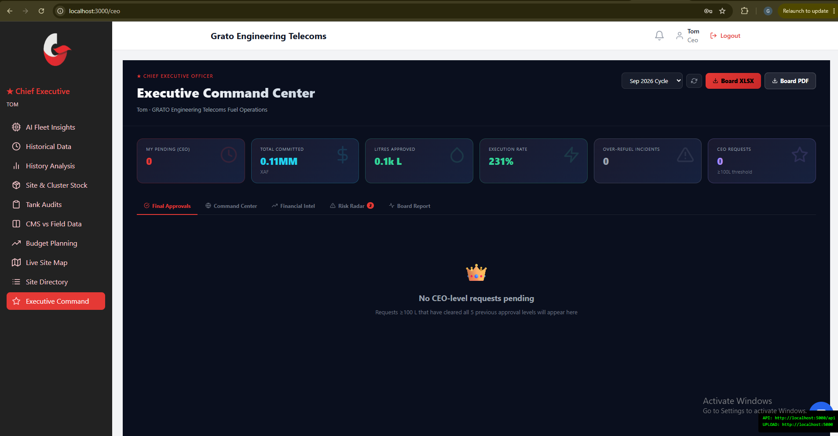
Figure 23. CEO Dashboard
Your dashboard has five tabs:
- Final Approvals — CEO-level requests with full approval history. Approve, Reject, or use the emergency-approve override.
- Command Center — org-wide live fuel health, spend velocity, a cluster map, and an efficiency heatmap.
- Financial Intel — cumulative spend curve, year-to-date totals, cost-per-cluster, and Tom Card vs. field delta.
- Risk Radar — over-refuel anomalies, theft flags, budget-exhaustion sites, and denial patterns.
- Board Report — a one-click board-ready Excel export with a summary, cluster table, and risk flags.

Chapter 5 — Delivery on Site
Once a request clears the approval chain (Chapter 4), it needs to actually reach the site. This chapter covers assigning a technician, the full mobile refueling flow, and reporting the delivery back.

5.1 Diesel Manager: Assigning a Refueler
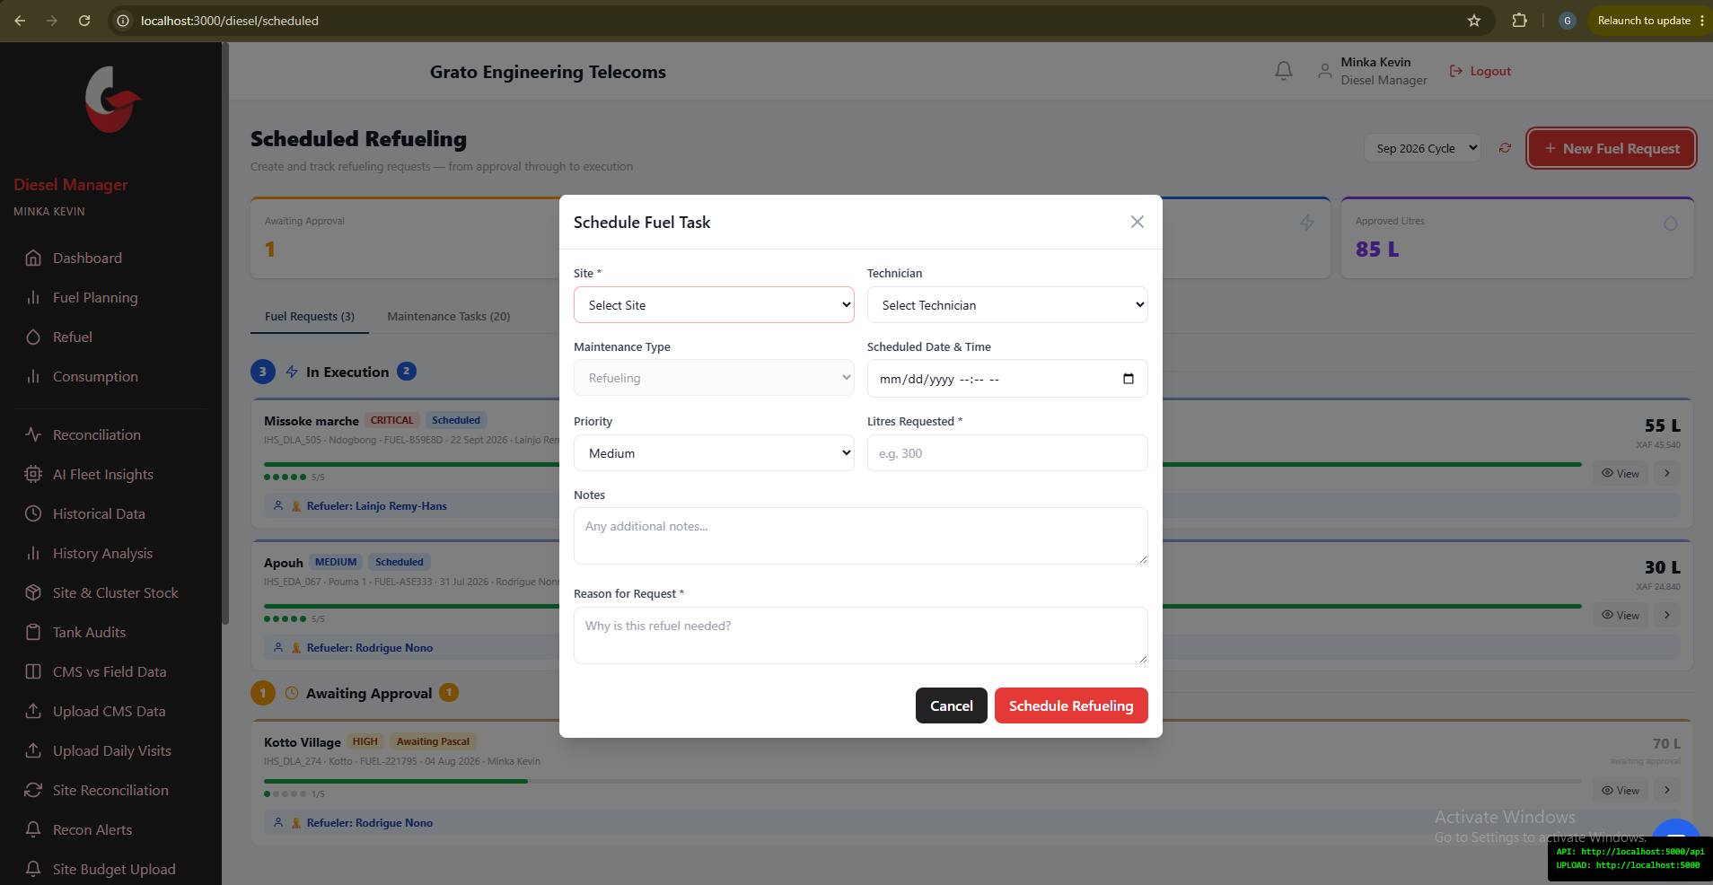
Figure 24. Schedule Fuel Task — Assign Refueler
From the Scheduled page (section 3.4), assign an approved request to a technician: pick the site and technician, confirm the litres requested, set a priority, and add a note if needed. The technician then sees it under My Fuel Assignments on their dashboard (section 5.3).

5.2 Technician: Refueling a Site
This is for reporting a refuel that is actually happening now — different from Request Fuel (section 3.3), which is for formally asking for approval before fuel is bought.

Step 1 — Refueling Site List
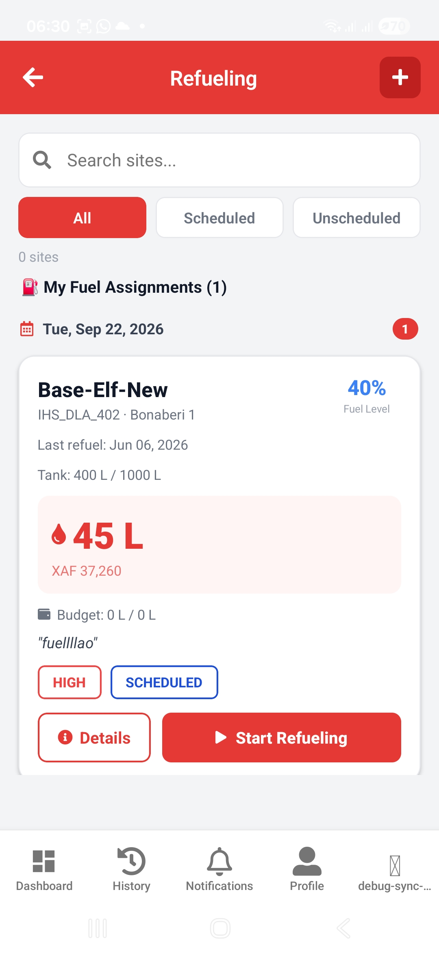
Figure 25. Refueling Site List
Use All / Scheduled / Unscheduled tabs, or search by name or ID. If you have approved fuel requests waiting to be delivered, they appear at the top under "My Fuel Assignments" — tap Start Refueling (or Resume, if you already bought fuel for it) on any of those cards. Otherwise tap any site card in the list below.

Step 2 — Activate Site
A short loading screen prepares (or resumes) your refueling workflow — always succeeds, even offline.

Step 3 — Select or Record a Fuel Purchase
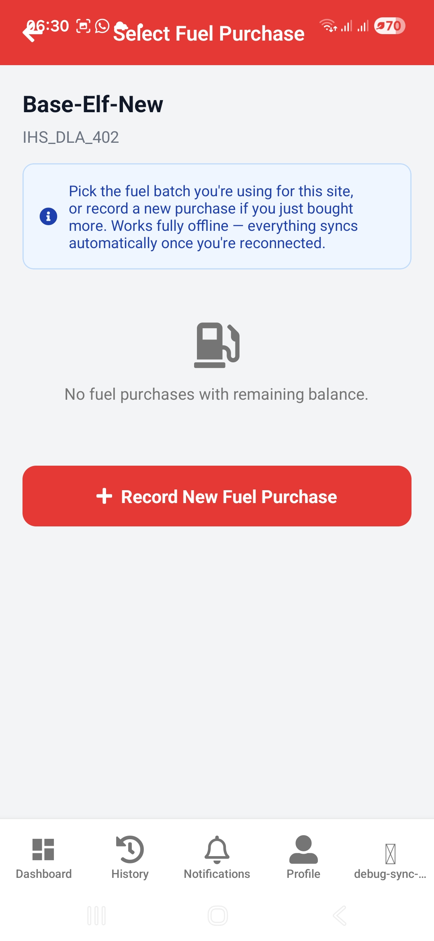
Figure 26. Select Fuel Purchase
Pick an existing fuel purchase with remaining balance, or tap Record New Fuel Purchase.
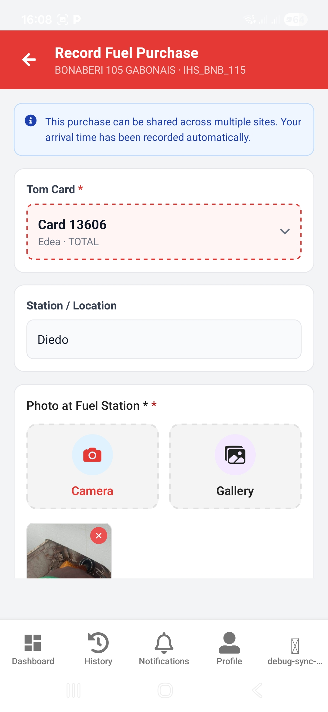
Figure 27. Record Fuel Purchase — Tom Card, Station, Photo
If recording a new purchase, enter:
- Tom Card used (required — pulled from the current cycle’s card list, section 3.2).
- Station / Location.
- Photo at Fuel Station (required).
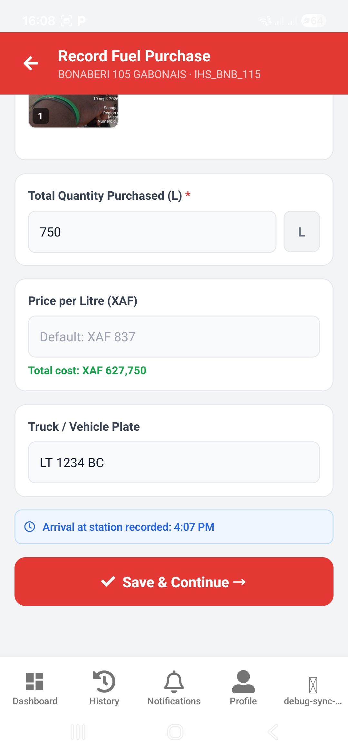
Figure 28. Record Fuel Purchase — Quantity, Price, Plate
- Total Quantity Purchased (L) and Price per Litre (XAF) — the total cost calculates automatically.
- Truck / Vehicle Plate.
Tap Save & Continue to proceed with this purchase for the current visit, or Save Purchase if you opened this screen on its own.

Step 4 — Check-In at Site
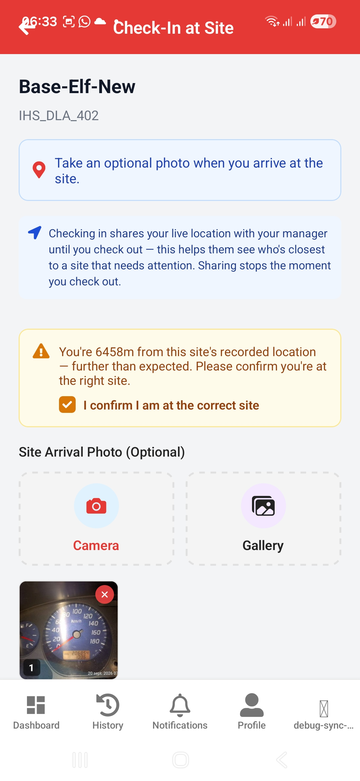
Figure 29. Check-In at Site
ℹ Note: Checking in shares your live location with your manager until you check out — this helps them see who is closest to a site that needs attention. Sharing stops the moment you check out.
The app automatically checks your GPS position against the site’s recorded coordinates. If you’re too far away, you’ll need to tick "I confirm I am at the correct site" before continuing. Add an optional arrival photo, then tap Check In & Open Form.

Step 5 — Refueling Entry Form
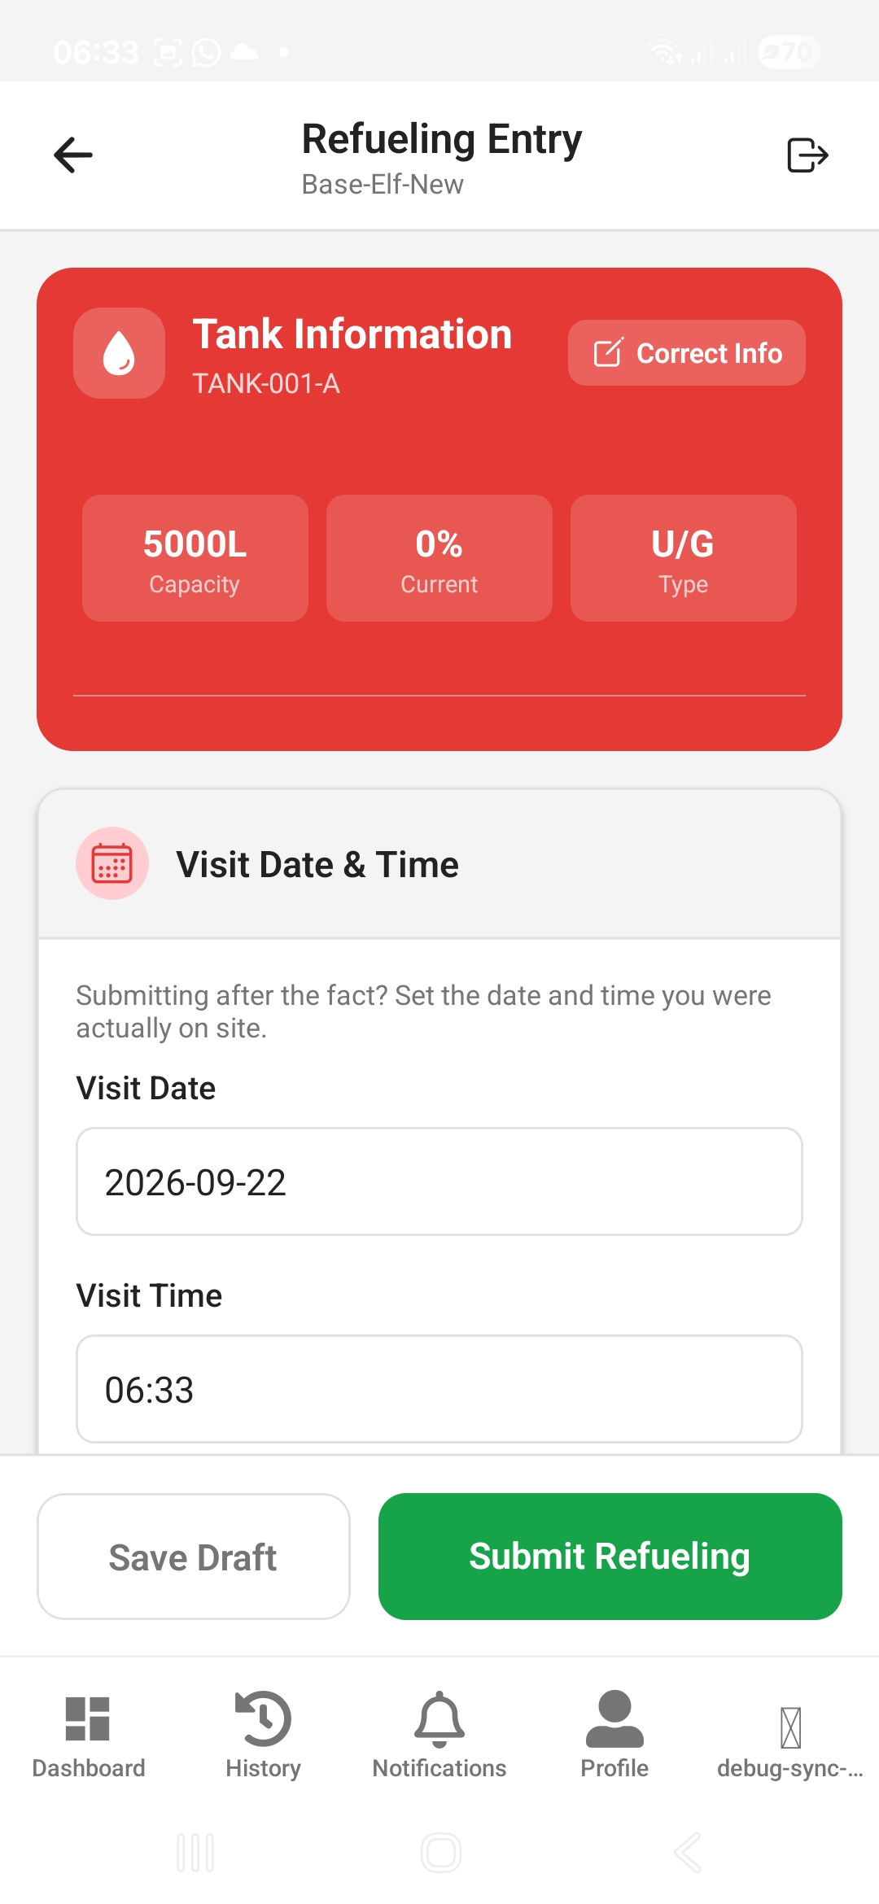
Figure 30. Refueling Entry Form — Tank Information
This is the main refuel report. Fill in, in order:
- Tank Information (edit if what’s on-site doesn’t match).
- Visit Date & Time, plus Refueling Start Time and End Time.
- Guard Information — name, number, and an optional photo.
- Measurement Information — Dip Stick Measurement Before and After (both required), Tank Length/Height/Width (required), Truck Plate Number, Truck Flow Meter readings, and photos.
- Meter Readings — the current reading (running hours since the last visit calculate automatically).
- Diesel Information — fuel found and fuel added (both calculate automatically from your readings).
- Documentation Photos (at least one required).
- Tank Observations and Fuel Sensor Status.
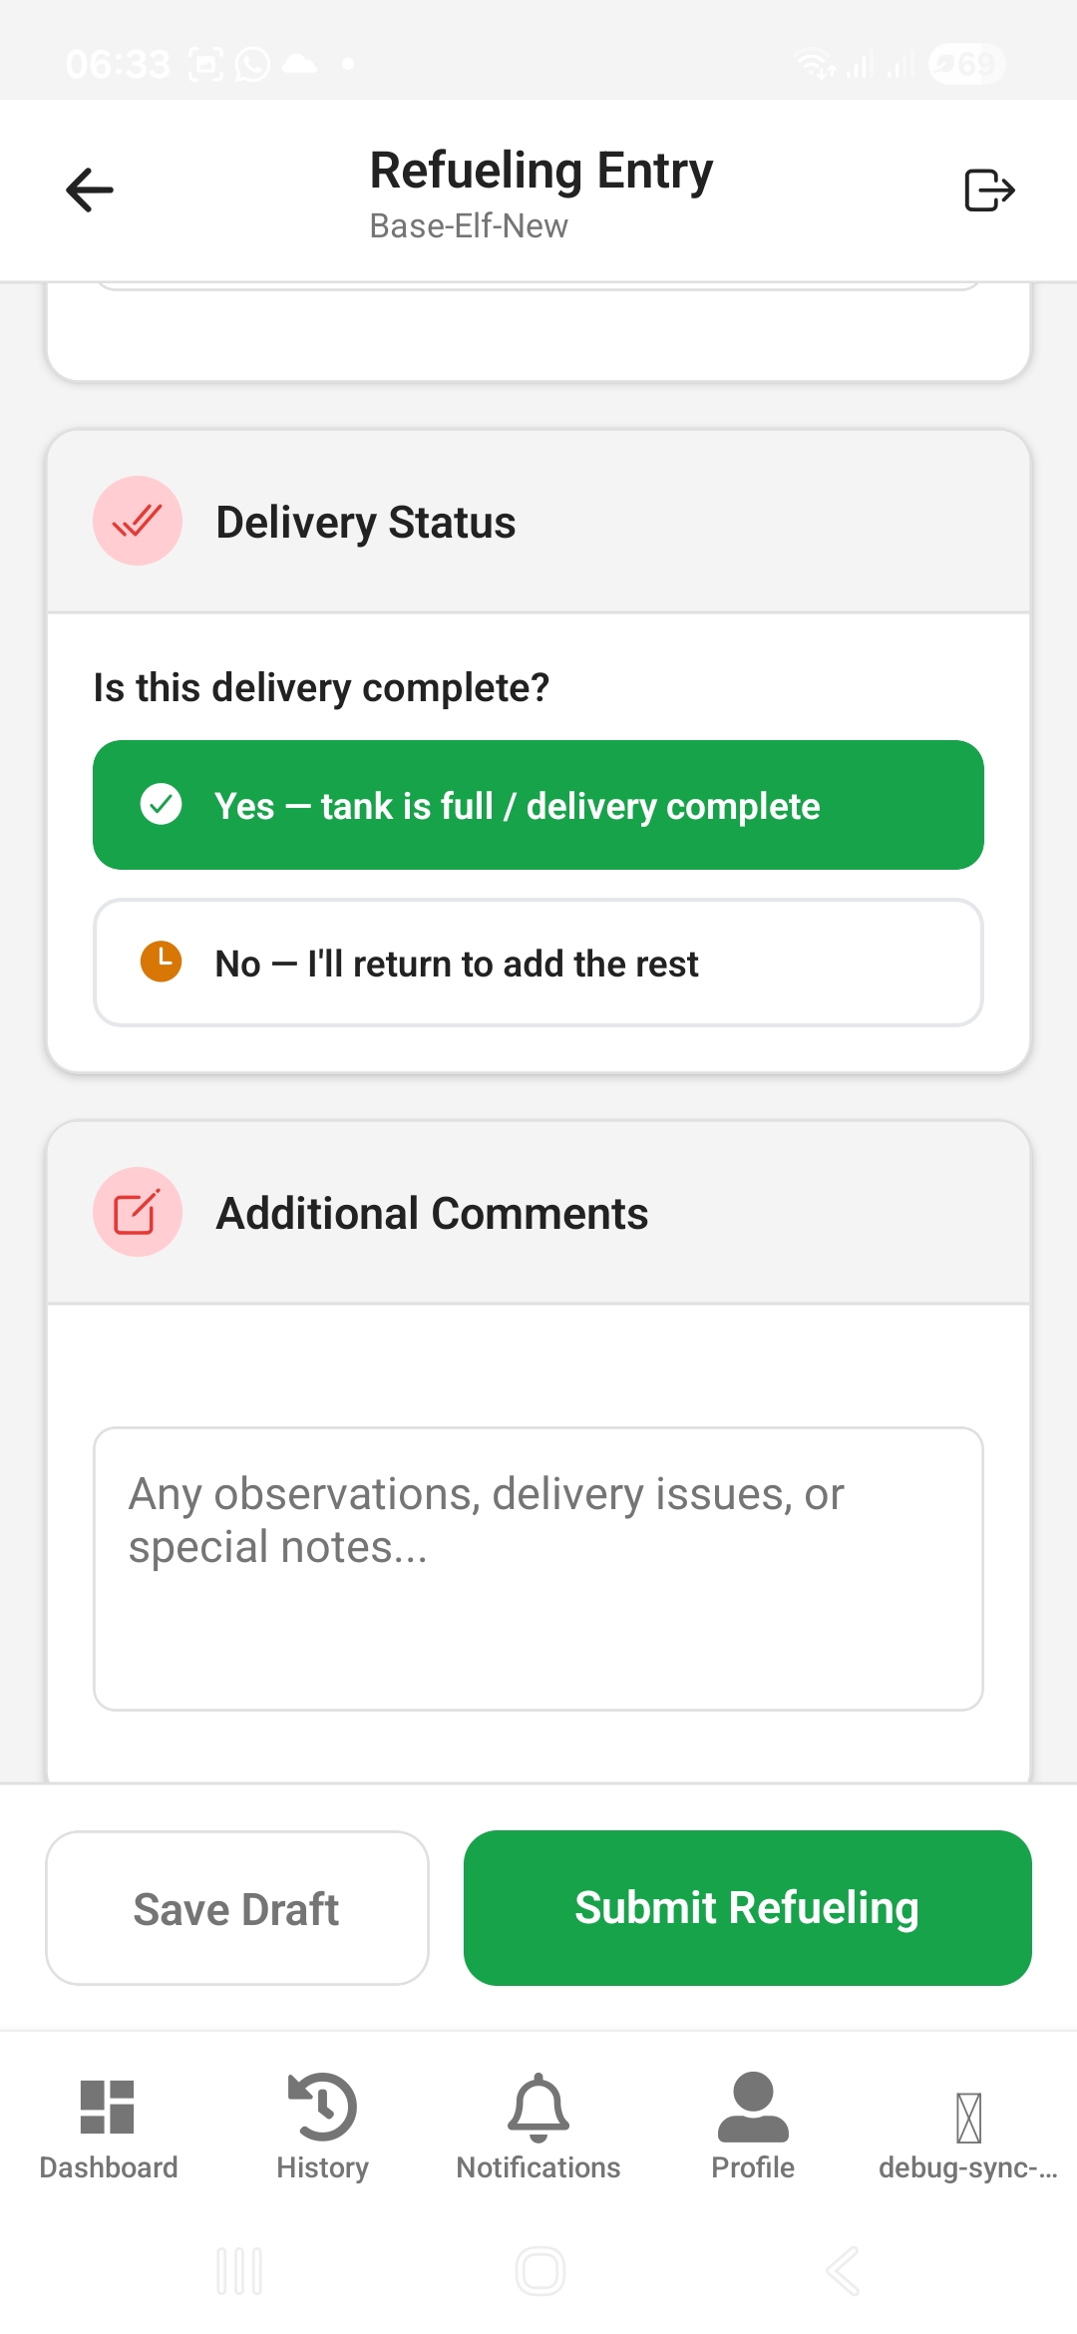
Figure 31. Refueling Entry Form — Delivery Status
Delivery Status — "Yes, tank is full / delivery complete" or "No, I’ll return to add the rest." Choosing "No" keeps the request open on your dashboard until you finish the delivery; the reserved litres stay set aside for this site. Add Additional Comments, then tap Submit Refueling once every required field is filled in.
ℹ Tip: Tap Save Draft at any point to save your progress locally. If you reopen the form for the same site later, you’ll be offered the chance to restore your draft.

Step 6 — Summary Before Submission
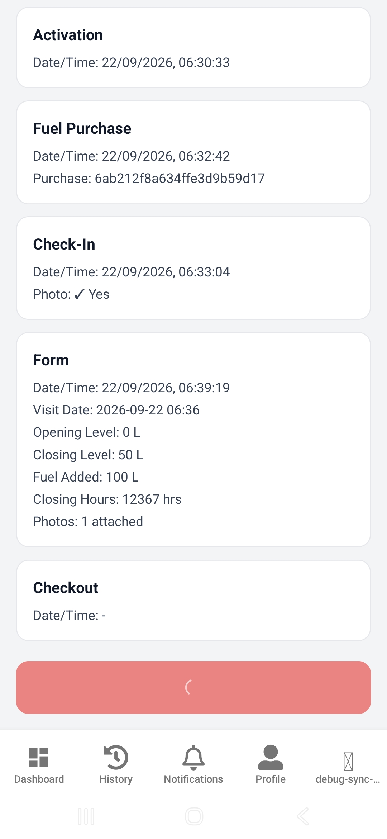
Figure 32. Summary Before Submission
Review the Activation, Fuel Purchase, Check-In, Form, and Checkout cards, then tap SUBMIT & FINISH. After this, the WhatsApp Share popup appears automatically — see section 5.4.

5.3 Technician: My Fuel Assignments
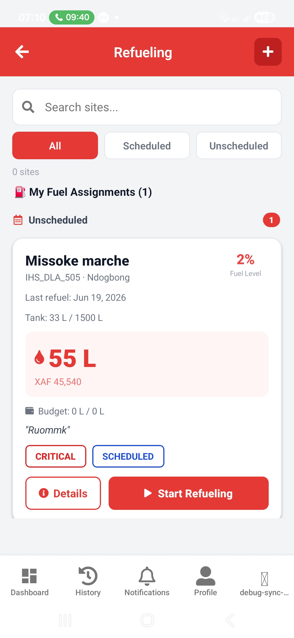
Figure 33. My Fuel Assignments
Once a request is approved and assigned to you (section 5.1), it appears here — tap Details to review it, or Start Refueling / Continue Refueling to begin delivering the fuel (this takes you into the same refueling flow as section 5.2, pre-filled with the approved amount).

5.4 Technician: Sharing a Refueling Report on WhatsApp
Right after you submit a refueling report, a popup offers to share a formatted summary — and your photos — to a WhatsApp group of your choosing.
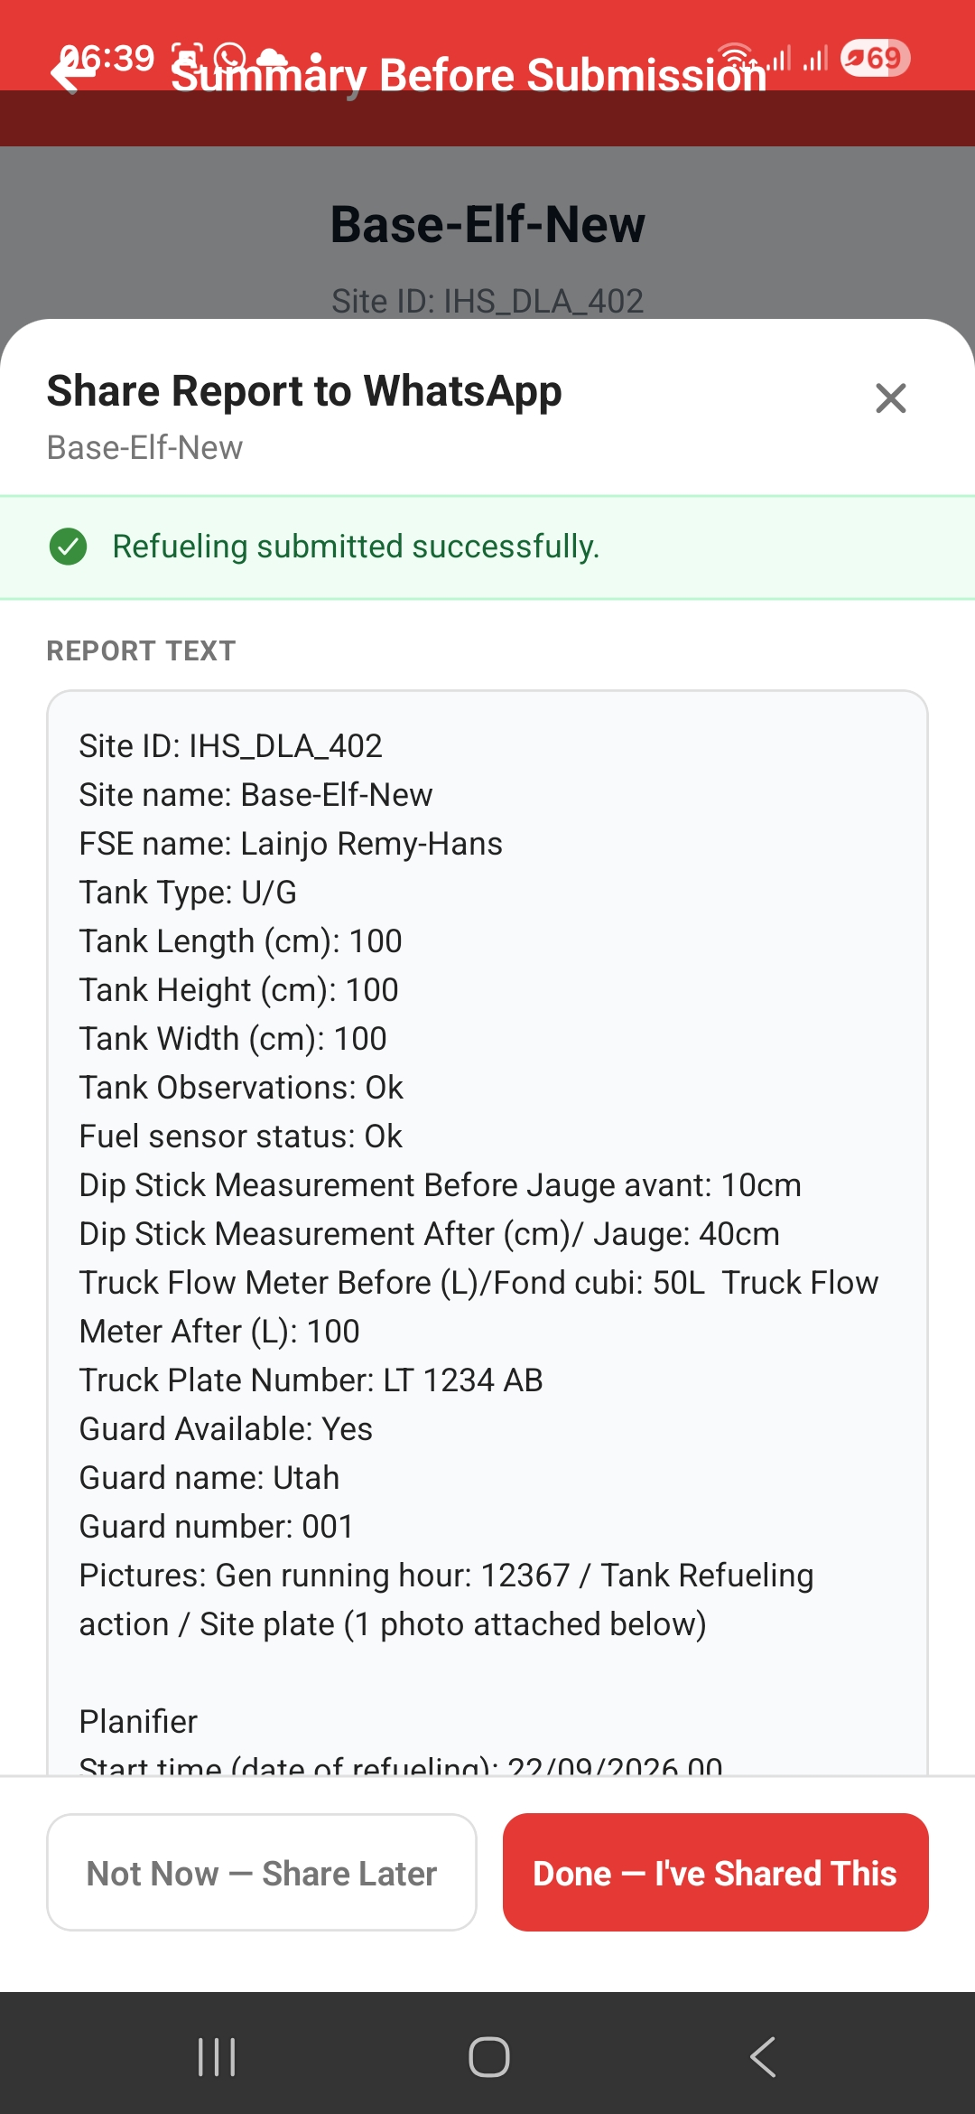
Figure 34. WhatsApp Share Popup — Report Text
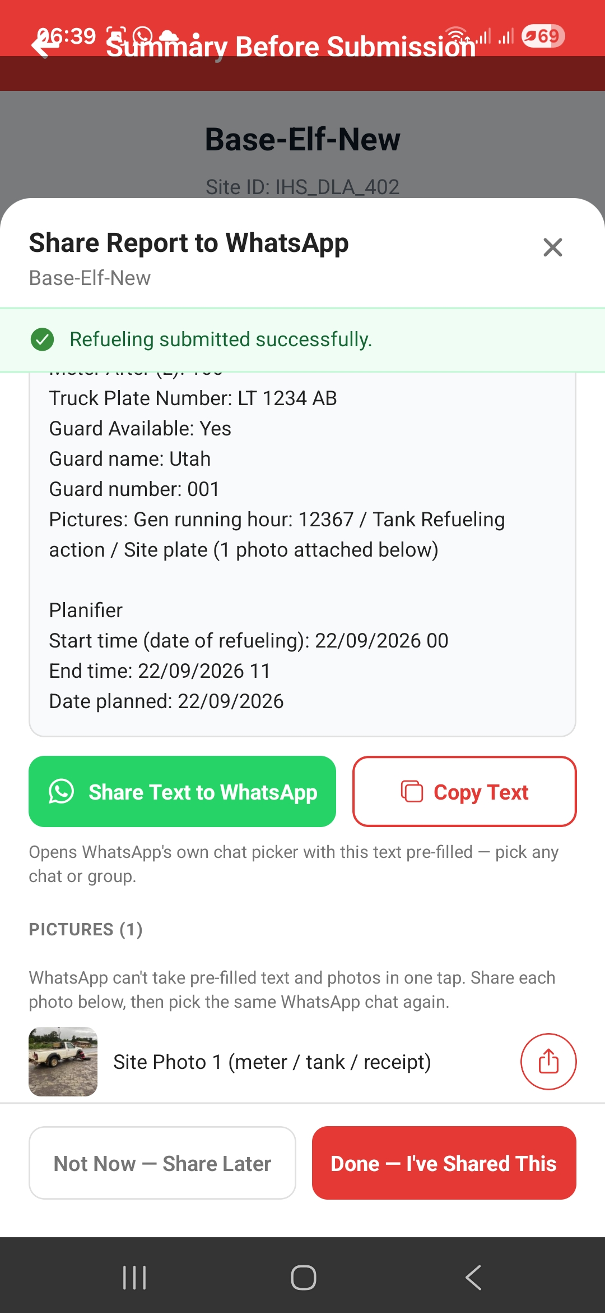
Figure 35. WhatsApp Share Popup — Pictures
- Share Text to WhatsApp — opens WhatsApp’s own chat/group picker with the report text already filled in. Pick the group and send.
- Copy Text — copies the report text to your clipboard as a backup.
- Each photo has its own share button — WhatsApp can only accept one photo at a time alongside pre-filled text, so tap each photo’s share icon and choose the same group again.
If you can’t share right away, tap "Not Now — Share Later" (or just close the popup) — nothing is lost. Once you have actually shared everything, tap "Done — I’ve Shared This" to clear it.

Pending WhatsApp Shares
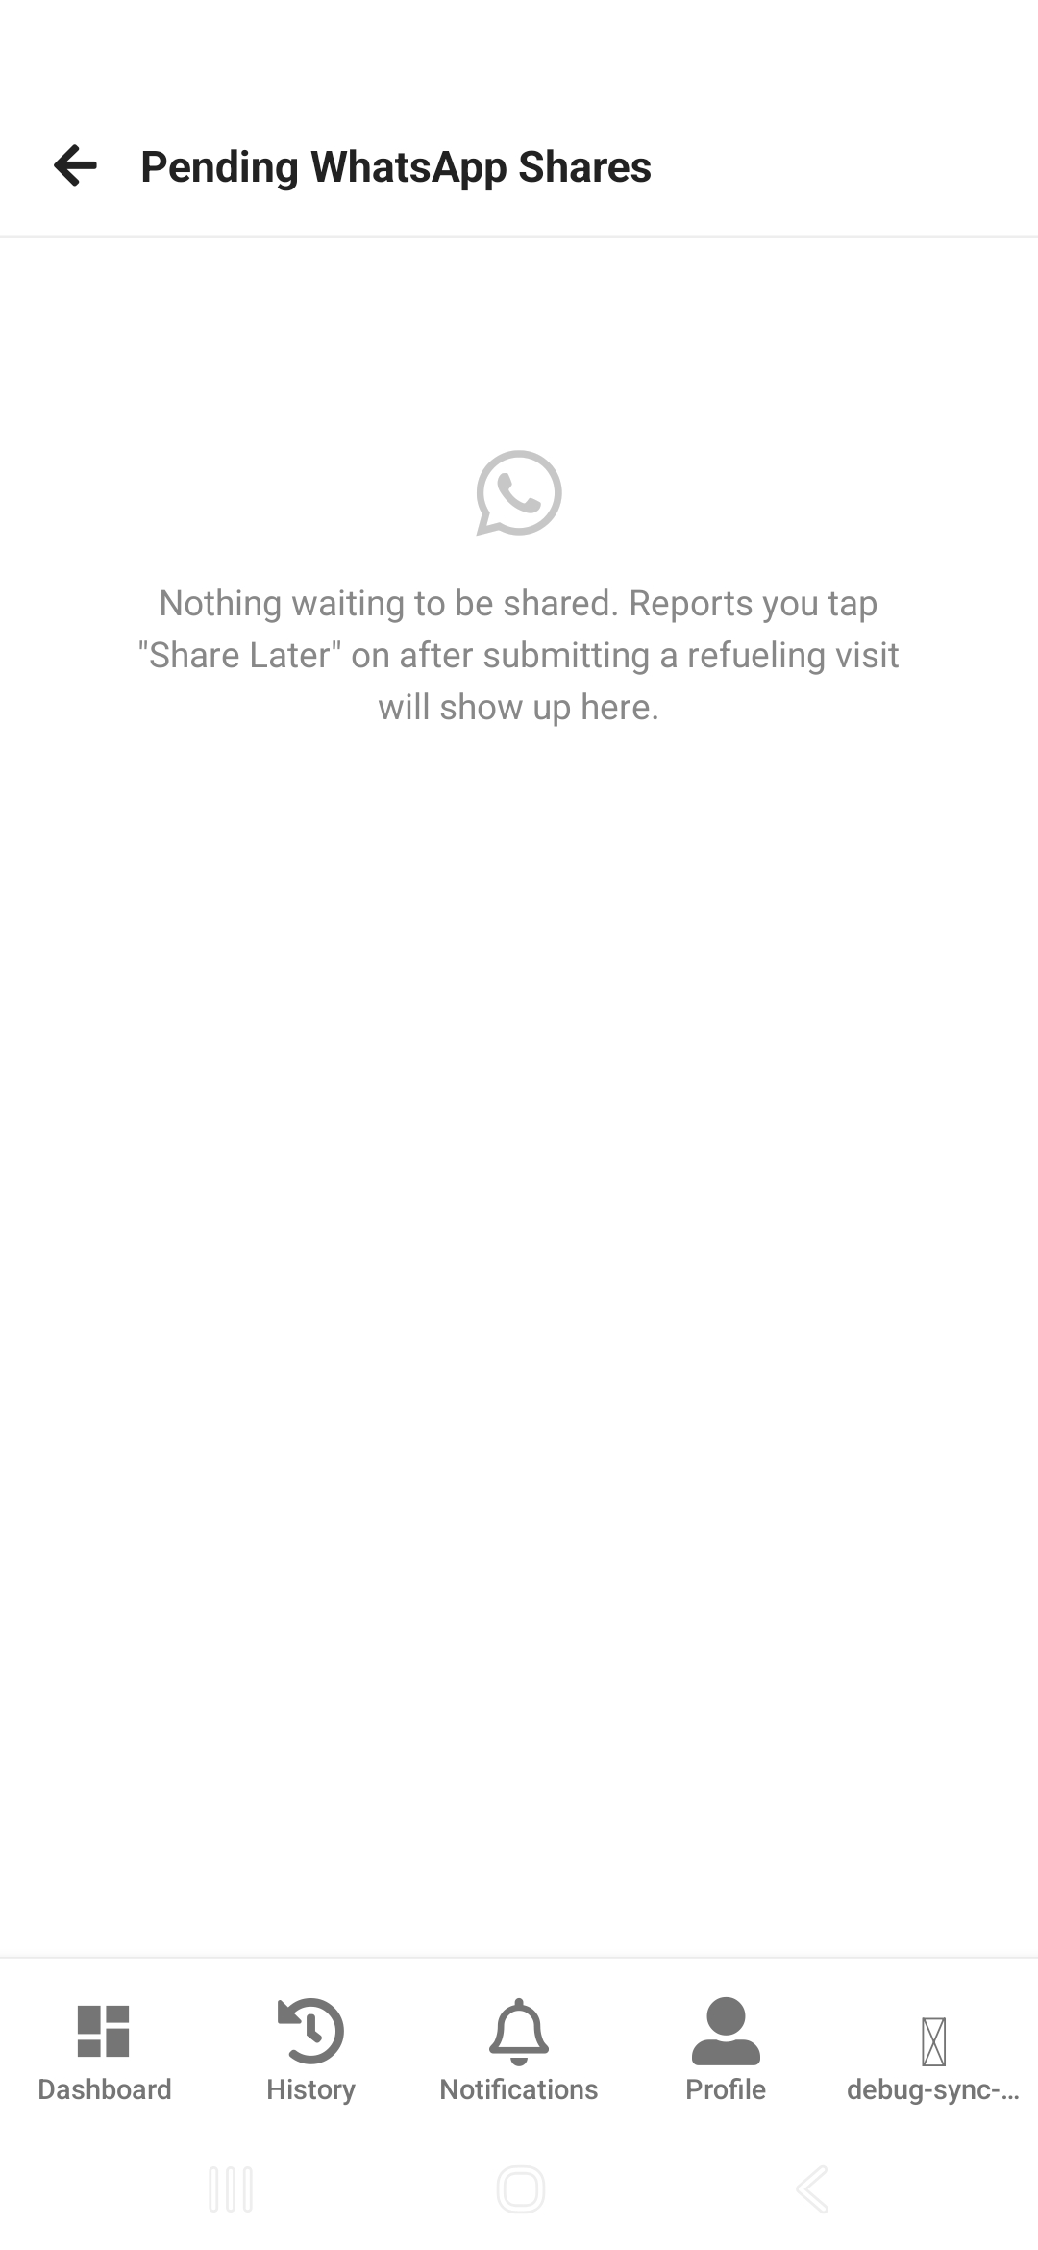
Figure 36. Pending WhatsApp Shares
Reach this from the green banner on your Dashboard. Every report you postponed is listed here with a Share Now button (reopens the same popup) and a Discard button if you no longer need to send it.

5.5 Technician: Submission History
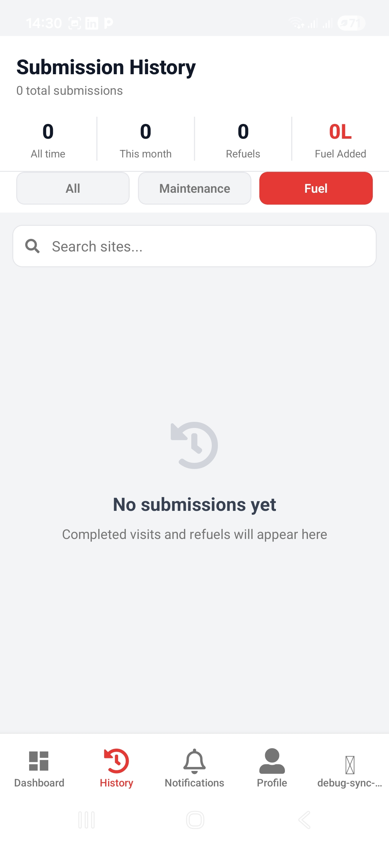
Figure 37. Submission History
Every fuel record you’ve submitted, searchable and grouped by month.

5.6 Diesel Manager: Tracking Consumption
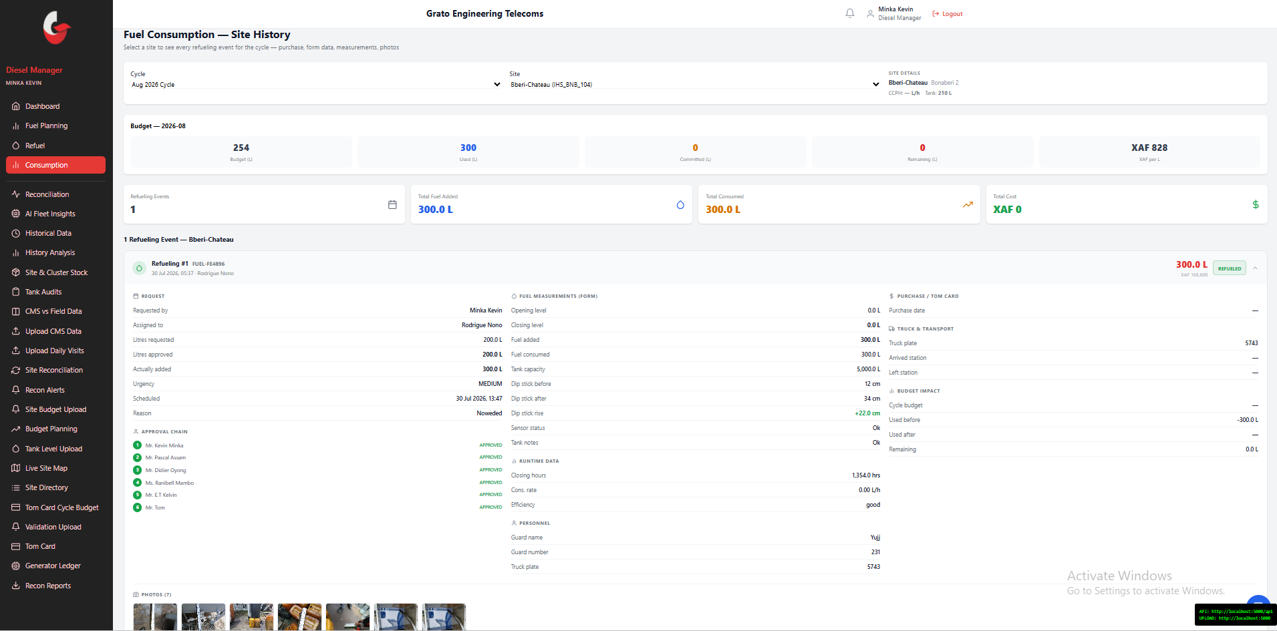
Figure 38. Consumption — Site History
A timeline of every refueling event at a site, for the selected cycle. Review each event’s request, purchase, form data, dip-stick measurements, photos, and runtime hours in one place — this is where a delivery reported on mobile becomes visible on the web.

Chapter 6 — Reconciliation
After fuel is delivered (Chapter 5), the system cross-checks what was budgeted, requested, purchased, and delivered against tank readings, telemetry, and card spend — to catch discrepancies, including possible theft, before they compound cycle over cycle. This is almost entirely the Diesel Manager’s work, with a short role for the Data Collector.

6.2 Diesel Manager: Site Reconciliation
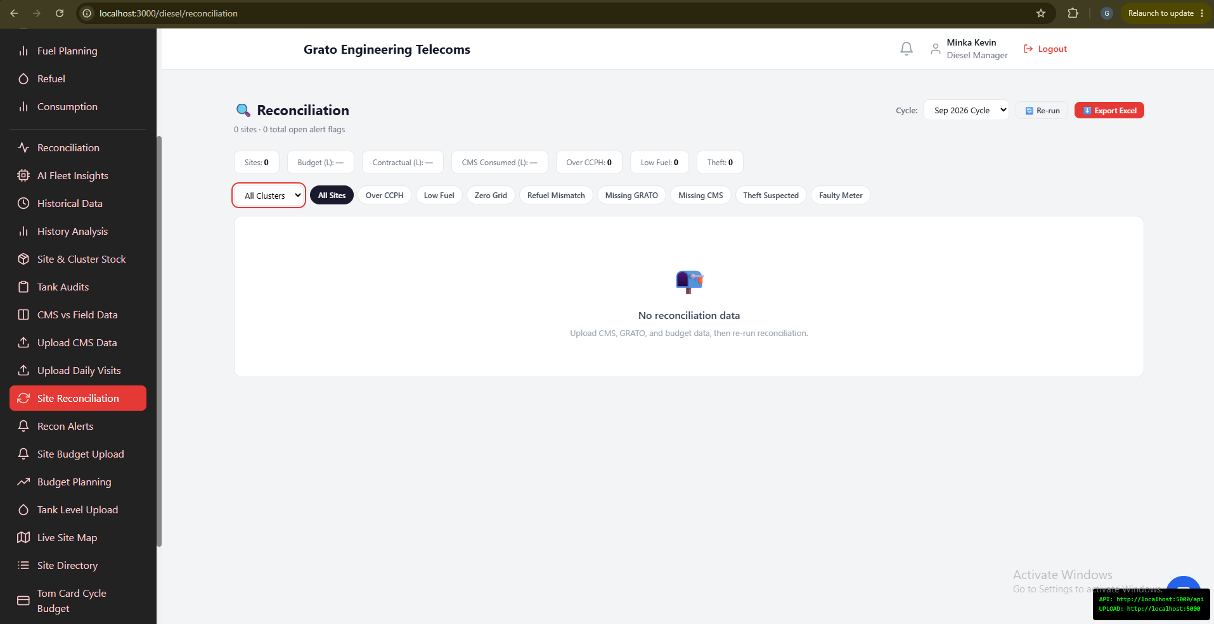
Figure 39. Site Reconciliation
The master reconciliation table — every site’s cycle KPIs with color-coded variance.
- Filter by cluster and alert type (Over CCPH, Low Fuel, Zero Grid, Refuel Mismatch, Missing GRATO/CMS, Theft Suspected, Faulty Meter).
- Click a row for a detail drawer.
- Run Reconciliation to re-trigger the calculation for the cycle.
ℹ Note: Admin users additionally see a Review form to record notes and override a site’s reconciliation status.

6.3 Diesel Manager: Recon Alerts
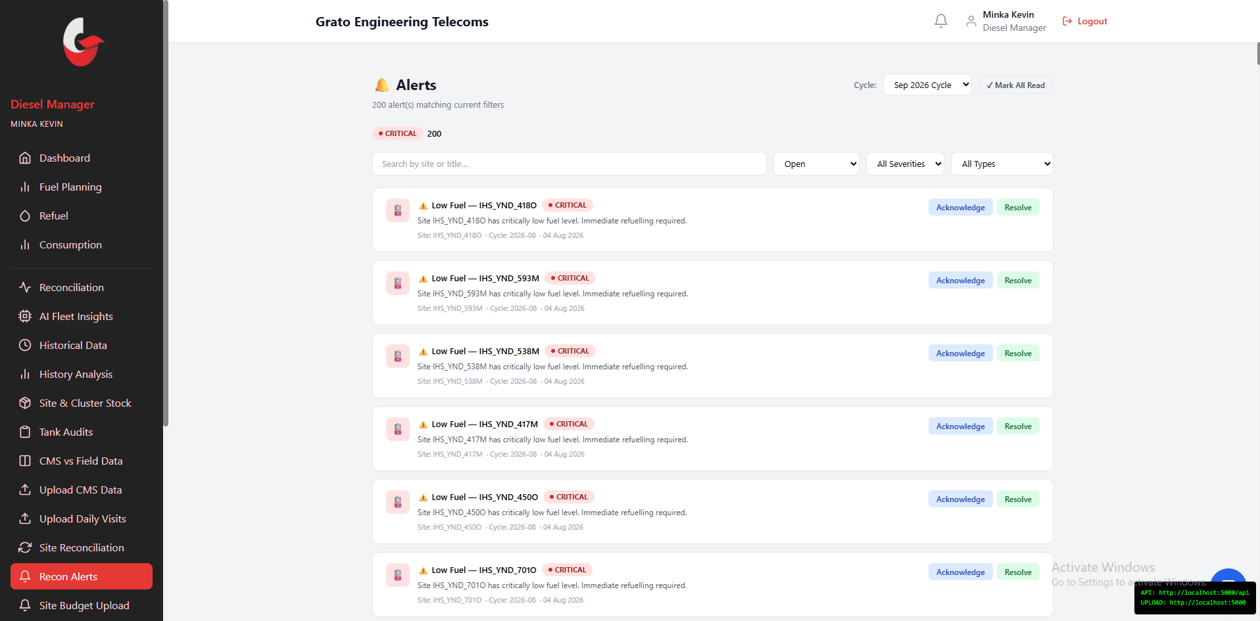
Figure 40. Recon Alerts
Full alert management for reconciliation issues.
- Filter by status, severity, and type; free-text search.
- Acknowledge, Resolve, or Dismiss any alert.
- Mark All Read.

6.4 Diesel Manager: Tom Card Management
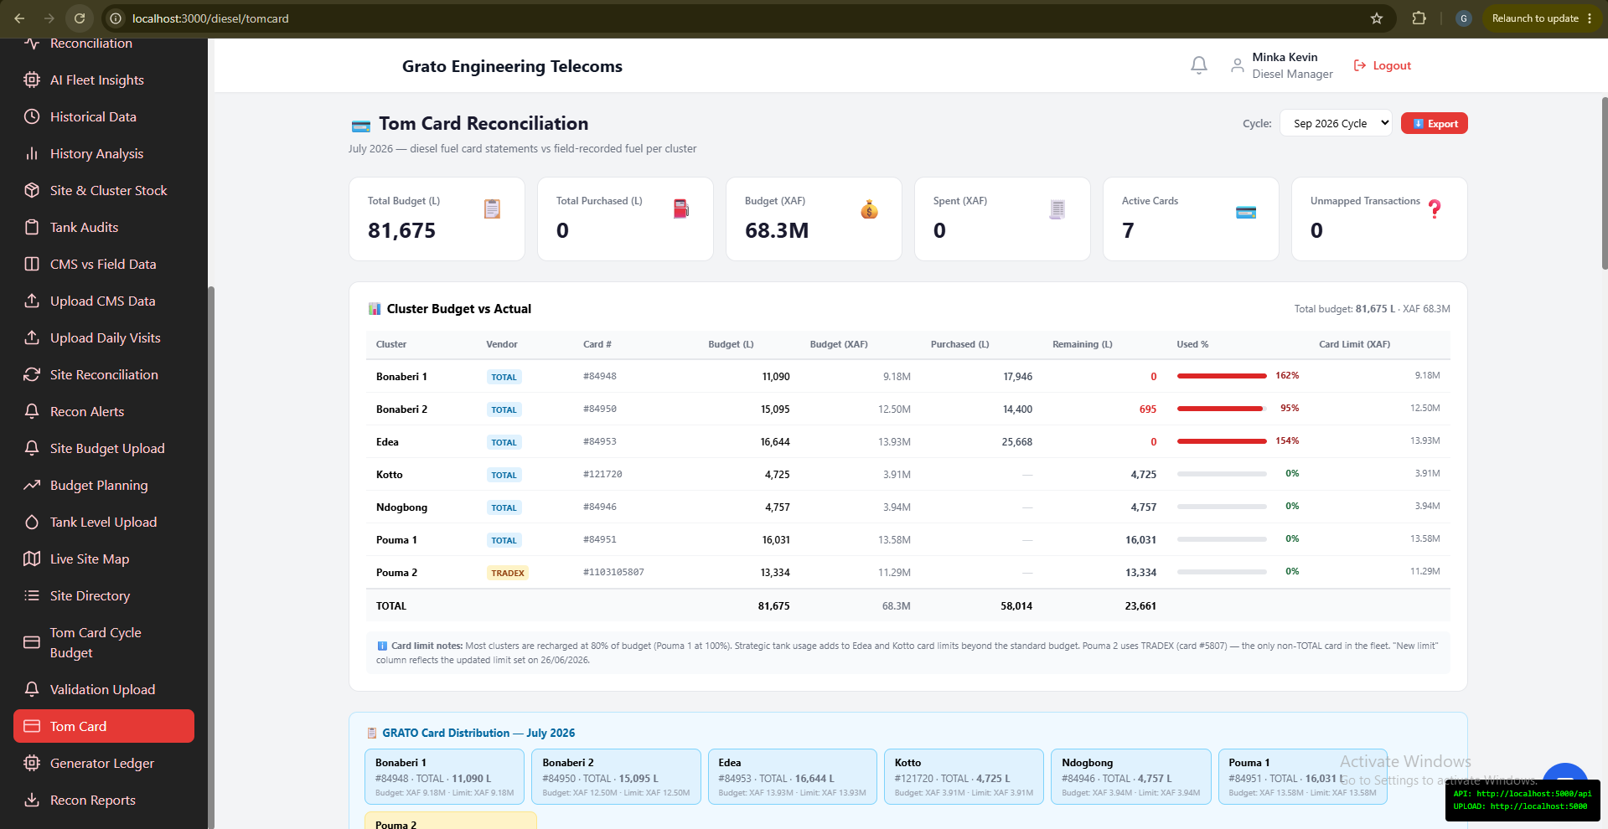
Figure 41. Tom Card Reconciliation
Fuel-purchase card management.
- Upload Tom Card transaction files.
- View the Cluster Budget Summary (budget vs. purchased vs. variance).
- Manage card-to-cluster/site mappings and view individual transactions.
- Export.

6.5 Tank Audits
A tank audit cross-checks a tank’s physical condition and fuel level three ways — a manual dip reading, the CMS/telemetry reading, and the theoretical stock level — and feeds directly into reconciliation and theft flags, which is why it’s covered here rather than with the equipment/HSE audits this manual leaves out.
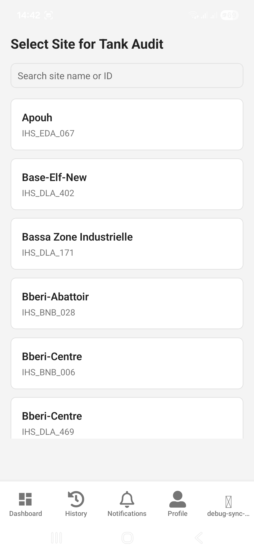
Figure 42. Select Site for Tank Audit
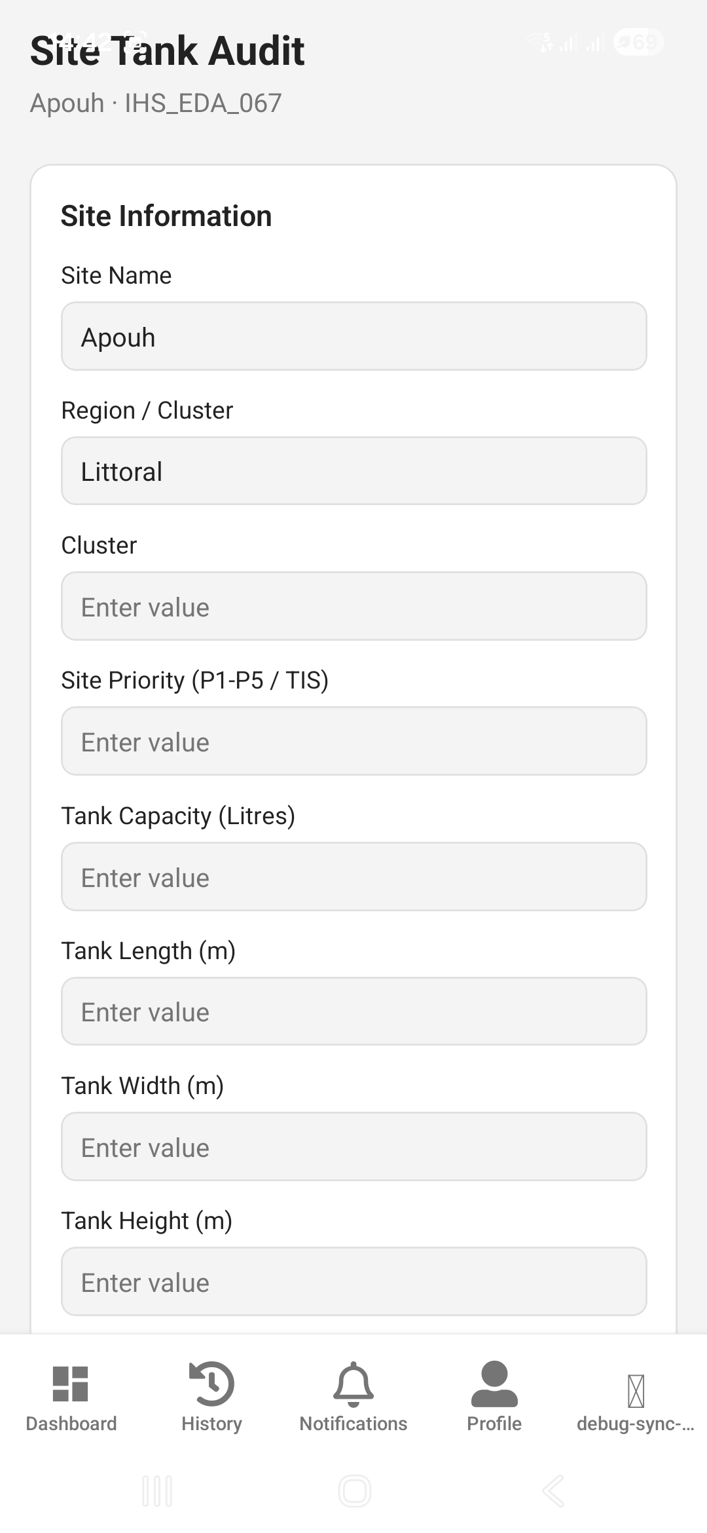
Figure 43. Site Tank Audit Form — Site Information
On the mobile app: eight physical checks are each rated OK / Issue / N/A — mark "Issue" to record a severity (Critical / Major / Minor) with notes and a photo. You must answer whether generator logs were collected before submitting.
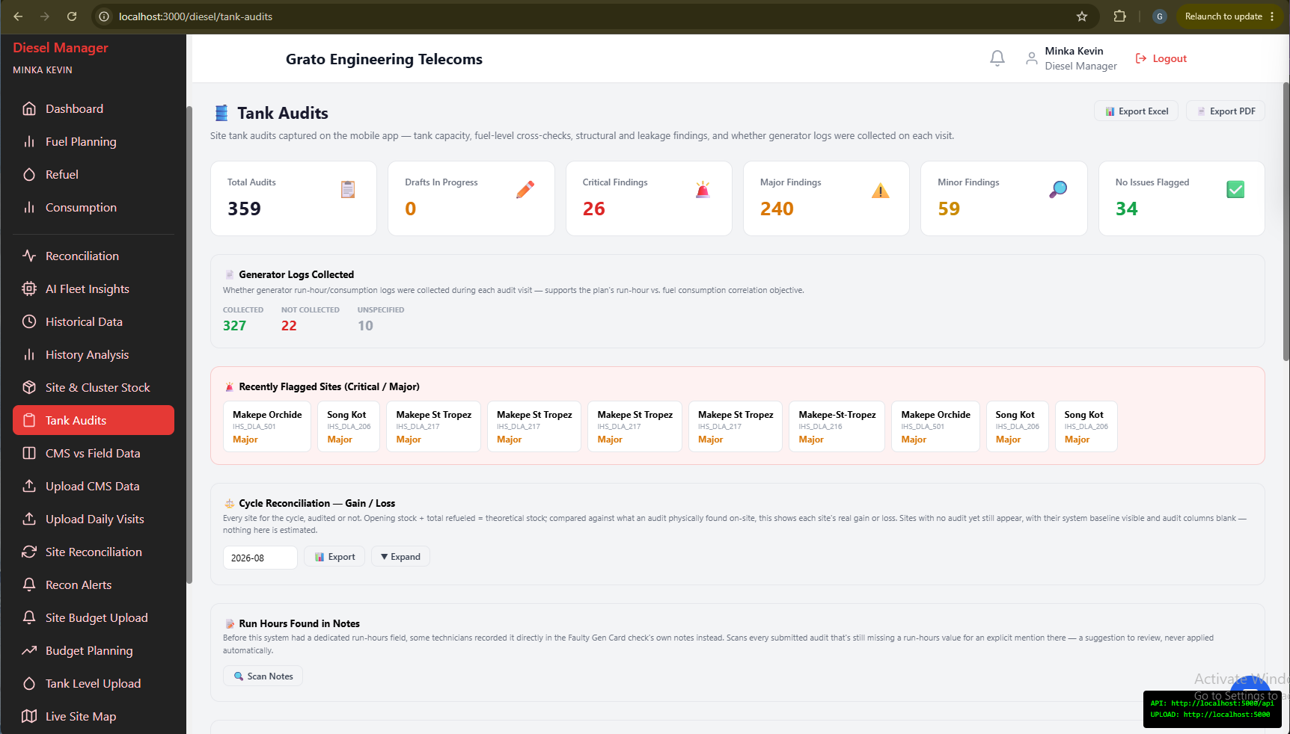
Figure 44. Tank Audits (Diesel Manager)
On the web dashboard: a read-only dashboard of every submitted tank audit.
- Review each audit’s 8 checks with OK/Issue/N-A ratings and severity where flagged.
- Export to Excel or PDF.

6.6 Diesel Manager: Generator Ledger
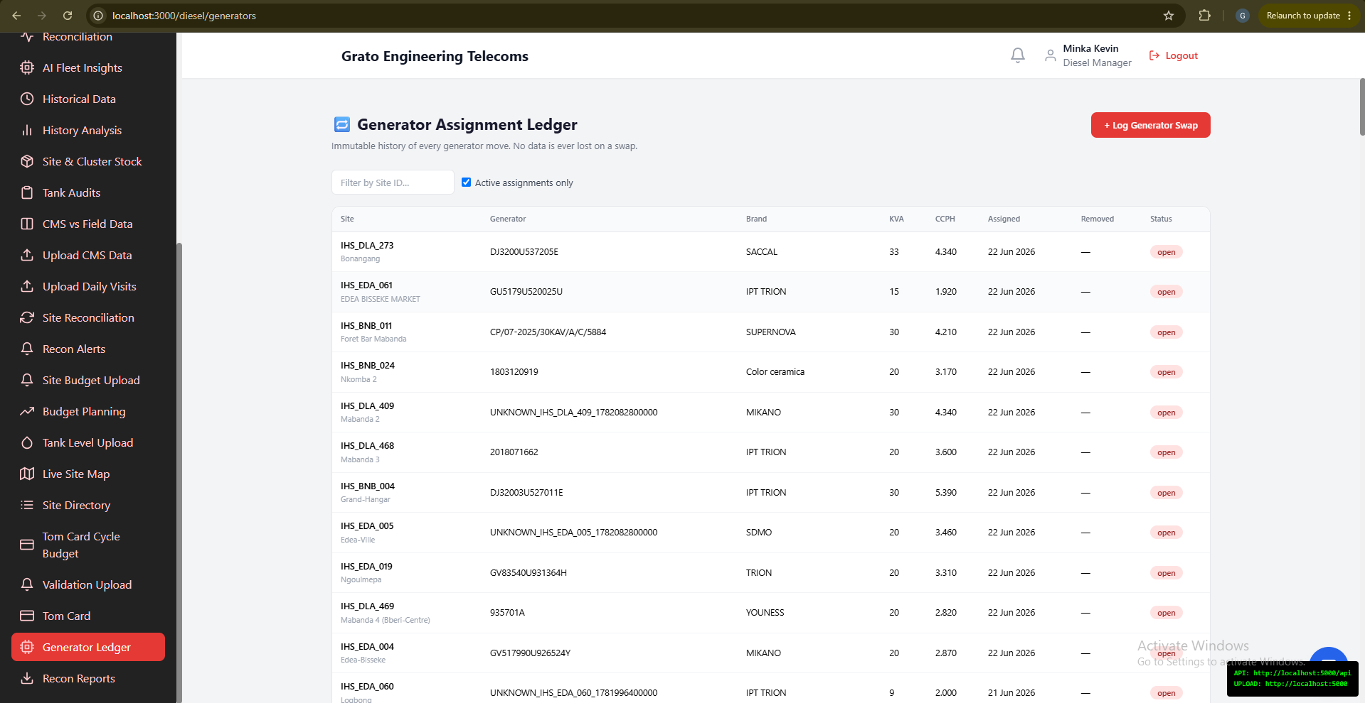
Figure 45. Generator Assignment Ledger
The immutable history of every generator assignment/swap per site.
- Filter by site, or Active-only.
- Log Generator Swap — records the old and new generator, closes the old assignment, and automatically triggers re-reconciliation for the affected cycle.
- View a site’s full swap history.

6.7 Diesel Manager: Site & Cluster Stock
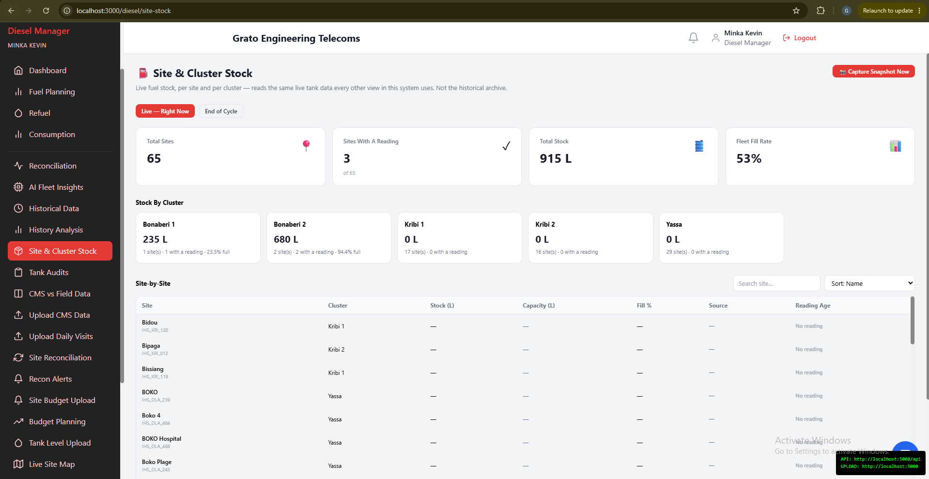
Figure 46. Site & Cluster Stock
Live and point-in-time fuel stock levels.
- Live view — current stock straight from the field, with an age indicator showing how stale each reading is.
- Cycle view — a stock snapshot captured for a past cycle (automatic at cycle close, or tap Capture to snapshot now).

6.8 Diesel Manager: CMS vs Field Data
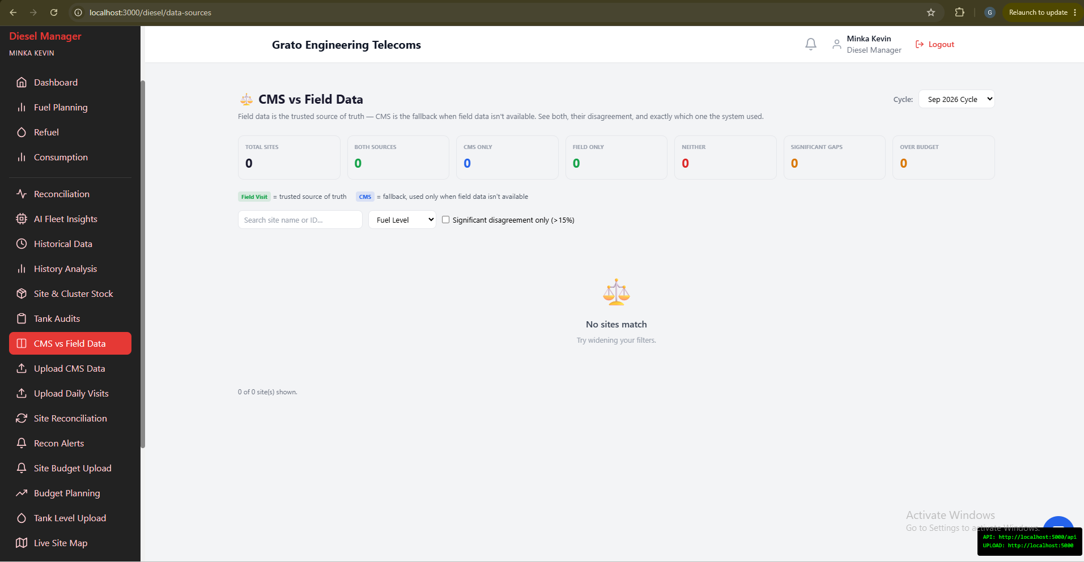
Figure 47. CMS vs Field Data
A transparency tool comparing CMS telemetry against field data, side by side. See the variance percentage per site per metric, and which source the system actually trusted (field data wins over CMS).

6.9 Diesel Manager: Historical Data & History Analysis
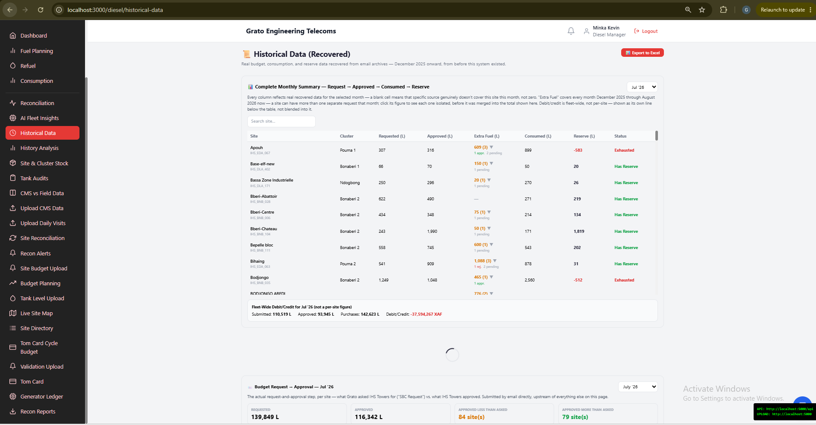
Figure 48. Historical Data (Recovered)
Real historical diesel records recovered from the pre-system, email-based process.
- View the complete monthly summary, per-site fuel reserves, and past ad-hoc/emergency request outcomes.
- Export to Excel.
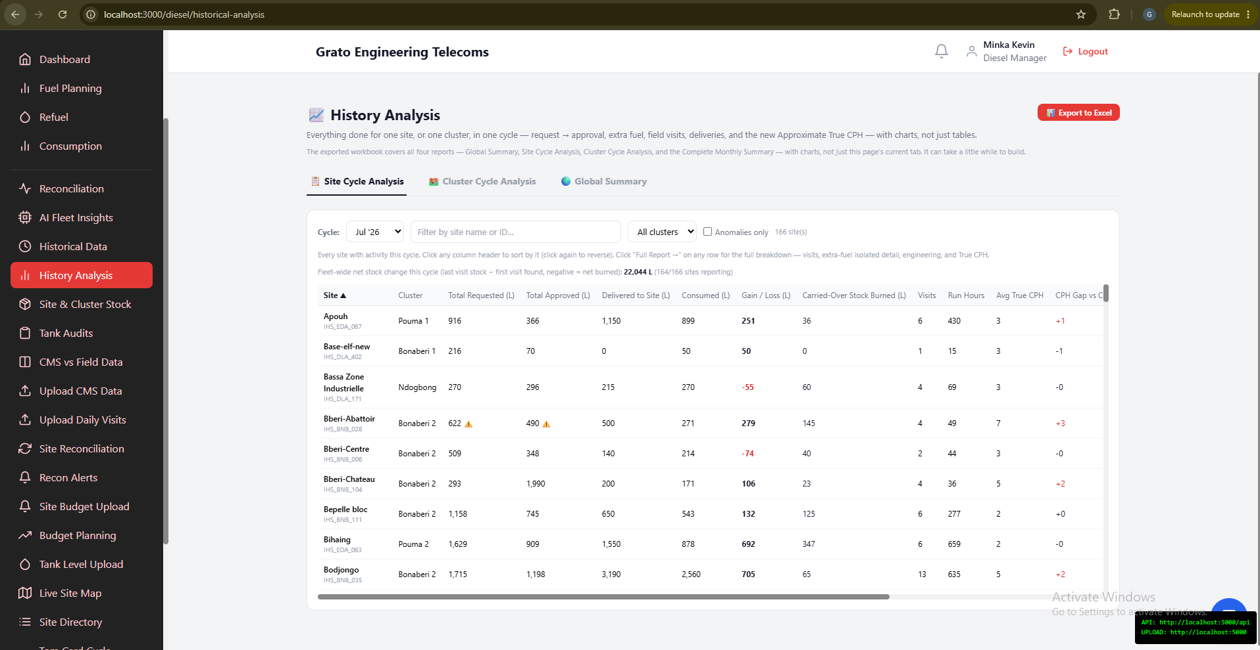
Figure 49. History Analysis
A deep-dive companion to Historical Data with full charts — build a consolidated "everything done for this site/cluster, this cycle" report.

6.10 Diesel Manager: Trends
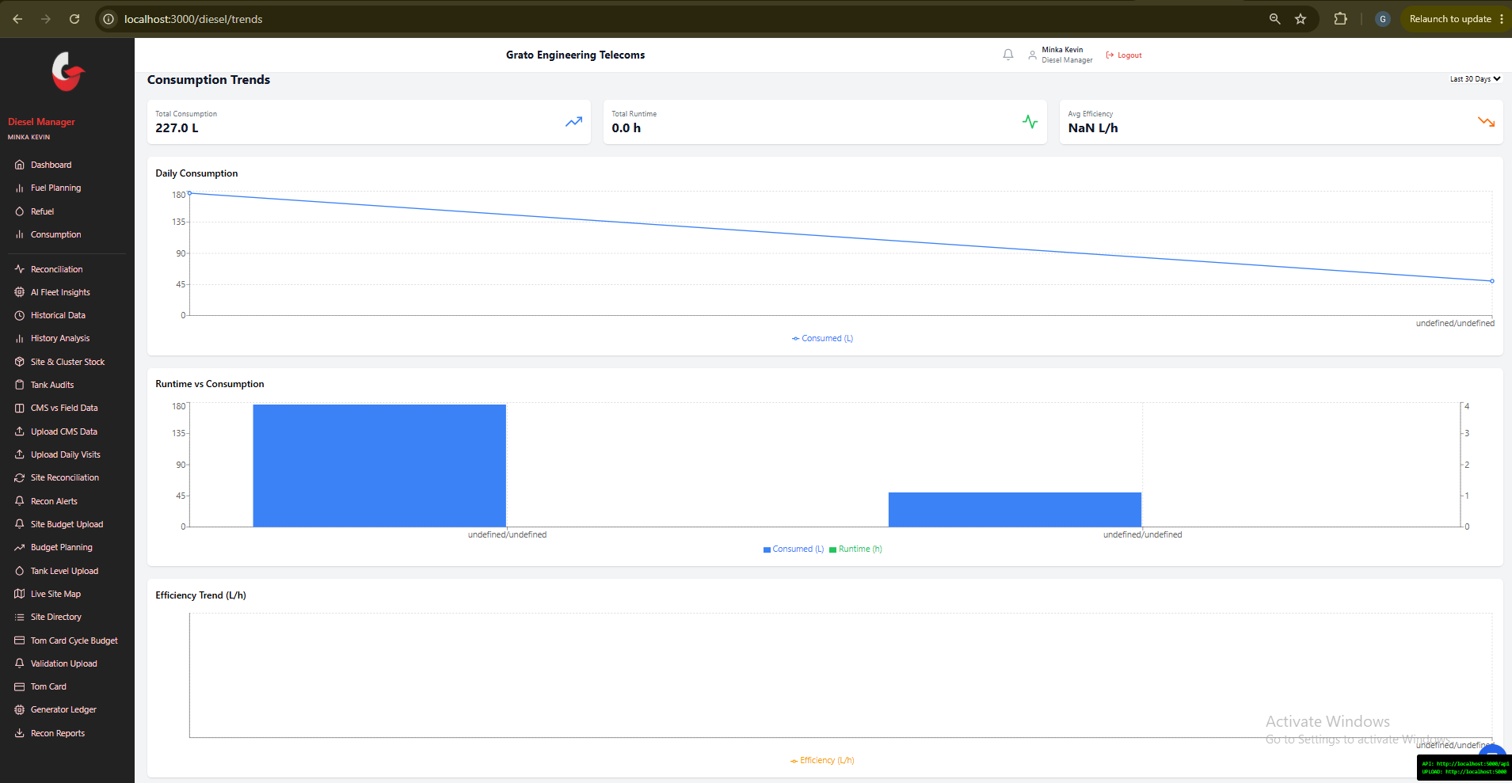
Figure 50. Consumption Trends
Consumption analytics over time. Choose a 7/30/90-day period and view total litres consumed, runtime hours, and average efficiency.

6.11 Diesel Manager: AI Fleet Insights
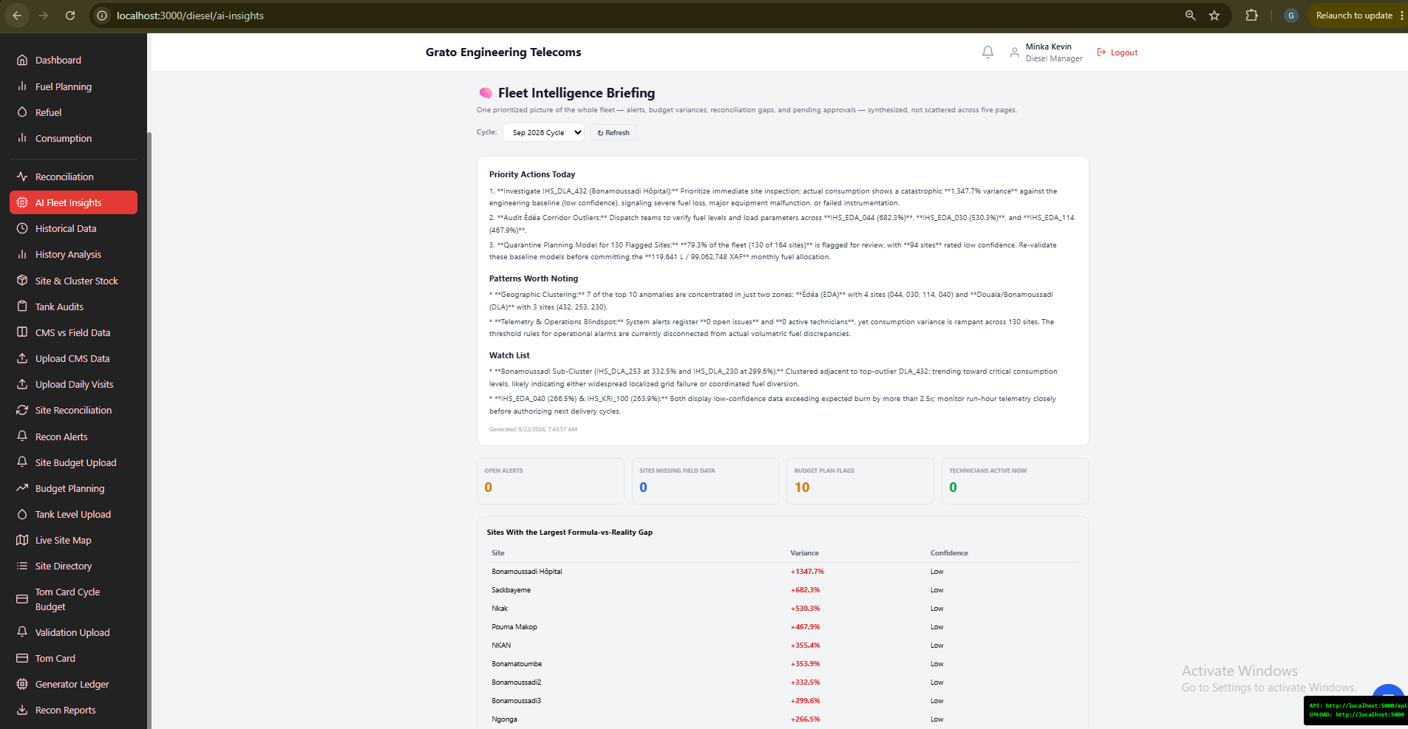
Figure 51. AI Fleet Insights — Fleet Intelligence Briefing
A cross-cutting briefing that pulls together alerts, reconciliation gaps, budget variances, pending approvals, and technician activity into one prioritized summary. Select a cycle and refresh to regenerate the briefing — the underlying evidence is always shown, even without AI.

6.12 Diesel Manager: Keeping the Data Current (Uploads)
Reconciliation (and Fuel Planning, Chapter 3) is only as good as the data behind it. These four pages are where that data comes in.
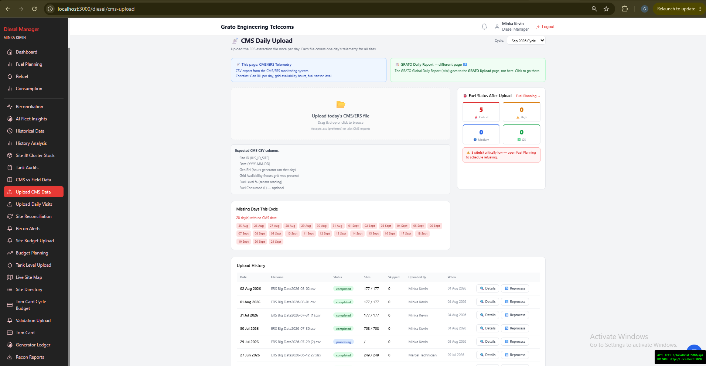
Figure 52. Upload CMS Data
Upload the daily ERS/CMS telemetry export — this feeds run-hour data into Fuel Planning.
- Select the cycle, then drag and drop the CSV/XLSX file.
- Check the "missing days" tracker to see which days still need data.
- Reprocess or view detail on a past upload.
ℹ Note: The page warns you if the file you’re about to upload looks like a GRATO report instead of CMS data.
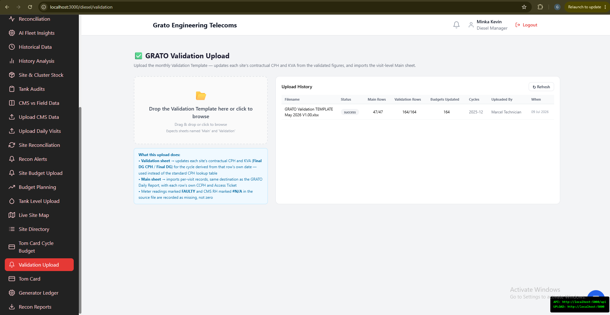
Figure 53. GRATO Validation Upload
Upload the monthly "GRATO Validation Template" (.xlsx with Main and Validation sheets).
- The Validation sheet updates each site’s contractual consumption rate and generator size.
- The Main sheet imports per-visit records, the same as the GRATO Daily Report below.
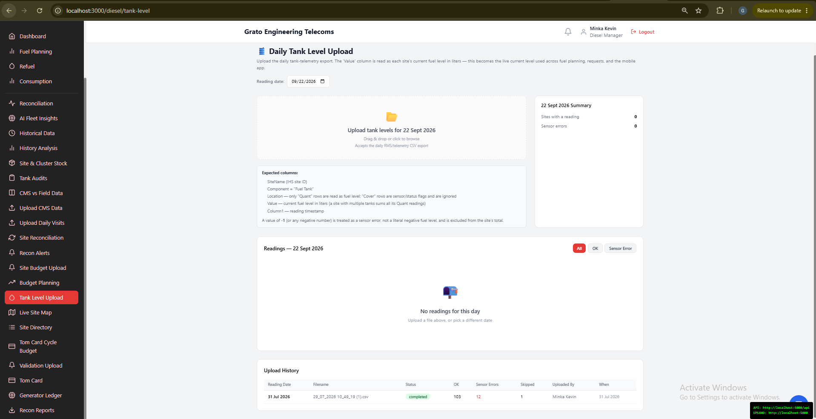
Figure 54. Tank Level Upload
Upload the daily RMS/telemetry tank-level export — this becomes every site’s current fuel level everywhere in the app, including the mobile app.
- Pick a Reading Date (defaults to today) before uploading.
- View readings filtered by status (all / ok / sensor error).
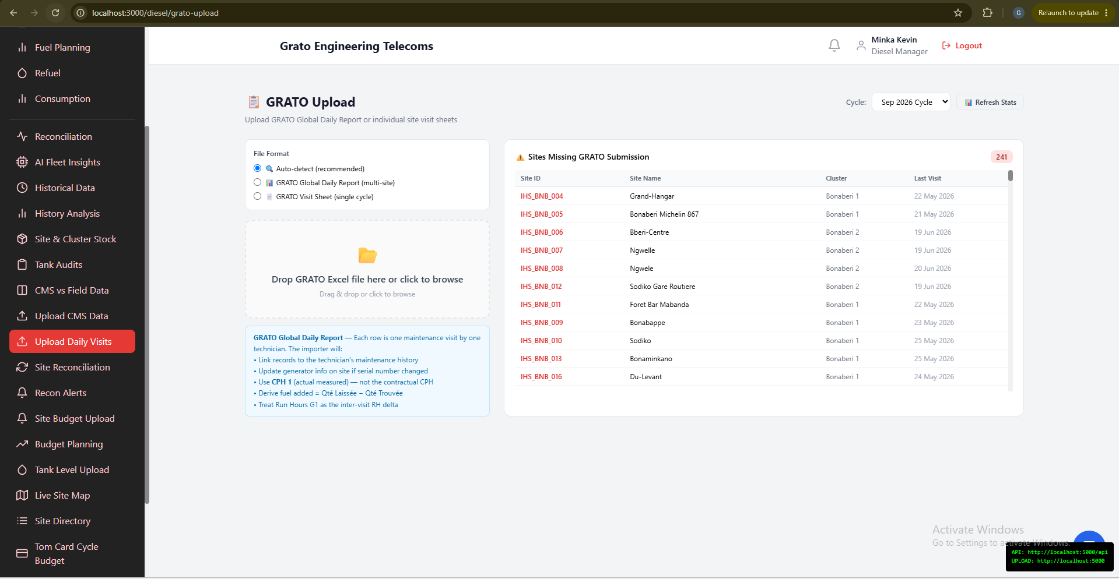
Figure 55. Upload Daily Visits (GRATO)
Upload the GRATO Global Daily Report, or individual per-site visit sheets.
- Auto-detect the file type, or choose manually between Daily Report and Visit Sheet.
- Review visit statistics by technician, cluster, and day.
- See which sites are still missing a GRATO submission for the cycle.

6.13 Diesel Manager: Recon Reports & Downloads
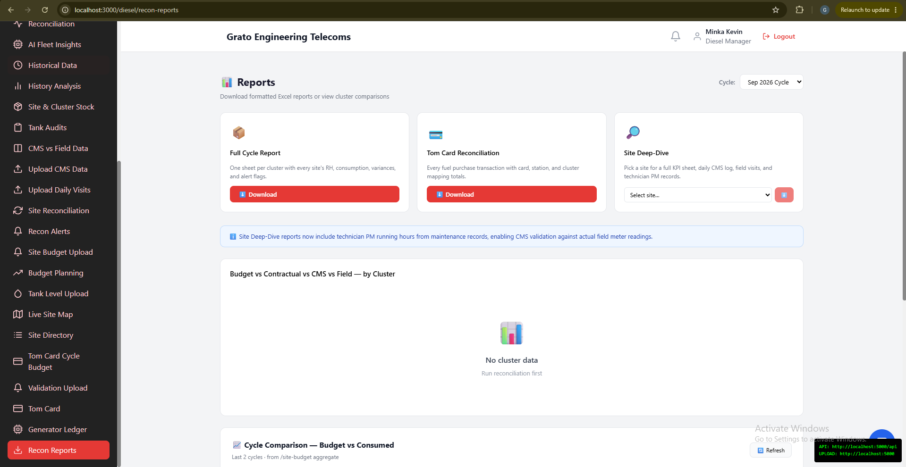
Figure 56. Recon Reports
Download center for cycle, site, and Tom Card reports.
- Download Excel reports for the selected cycle.
- View a 6-cycle historical cluster comparison chart (budget vs. consumed).

6.14 Data Collector’s Role
Data Collector accounts share access to four of the upload pages above — Upload CMS Data, Upload Daily Visits (GRATO), GRATO Validation Upload, and Recon Alerts — for keeping data flowing in even outside the Diesel Manager team. There is no separate walkthrough for these; they work exactly as described in sections 6.3 and 6.12. Everything else in the Data Collector portal (data-quality scoring, missing-data reports, general exports) is about overall site-visit data completeness, not diesel specifically, and is out of scope for this manual.

6.15 Operations’ Role
The Operations portal has no diesel-specific responsibilities. Its entire purpose is reviewing the comprehensive site audit — a broad equipment/HSE inspection covering janitorial condition, generators, grid, air conditioning, and similar — which is outside this manual’s scope.

Chapter 7 — Emergency Refueling Quick Reference
This page summarizes how emergency (Critical-urgency) fuel requests work, for anyone in the approval chain.

12.1 For the Technician Raising the Request
- Open Request Fuel on the mobile app (works for any site, scheduled or not).
- Set Urgency to Critical only for a genuine emergency.
- Submit — the app confirms it went into the approval chain.

12.2 For Approvers (Diesel Coordinator, Operations Manager, Technical Director, Finance, Head of Business, CEO)
- A Critical request appears on your dashboard immediately — you do not need to wait for anyone earlier in the chain to act first.
- If you approve it, the request is scheduled immediately, and everyone else in the chain is notified that it’s already resolved — no further action needed from them.
- If someone else approves it first, it will no longer appear as pending for you.
ℹ Note: A normal (non-Critical) request always goes through all six levels in order, one at a time, exactly as described in section 4.1.

Chapter 8 — Glossary
Approval Chain — The ordered list of people (Diesel Coordinator, Operations Manager, Technical Director, Finance, Head of Business, CEO) who must approve a fuel request before it can be scheduled.
Cycle — A billing period, usually one calendar month (e.g. "2026-09"), used to scope budgets, requests, and reconciliation.
CCPH — Contractual Consumption Per Hour — the agreed diesel-burn rate used to calculate a site’s expected consumption.
CMS — The telemetry/monitoring system that reports generator run-hours and related data automatically.
Dip Stick Reading — A manual physical measurement of fuel level in a tank, taken before and after refueling.
Emergency Refueling — A fuel request marked Critical urgency, which routes to every approver at once instead of one at a time — see Chapter 7.
GRATO Report / Visit Sheet — The site-visit record format uploaded to track field activity and consumption.
Reconciliation — The process of cross-checking tank readings, field visits, telemetry, and fuel purchases against each other to catch discrepancies (including possible theft).
RMS — Remote Monitoring System — the source of automated tank-level telemetry readings.
Scheduled (status) — A fuel request that has completed approval and is ready for (or already assigned to) a refueler.
Site Budget — The litres/XAF a site is allocated for a given cycle.
Tom Card — A fuel-purchase card used at the pump, tracked against a cluster/site budget.
Urgency — The priority level of a fuel request: Low, Medium, High, or Critical (Critical = Emergency Refueling).

